

**PROGRAMME TITLE: EBRD UNCITRAL Public Procurement Reform Initiative**

***Blueprint for closed***

***Framework Agreements***

***September 2021***

**APPROVAL PAGE**

Date

This document for “Blueprint for closed Framework Agreements” of the project “*Name of the project*” was first prepared as a draft and submitted on the *date* by the Consultant. It has gone through a number of iterations, and this version 1.0 is the final version. The document has been examined by the EBRD OL and the representatives of the Government Client/Beneficiaries and is hereby recommended for approval and acceptance.

|  |  |
| --- | --- |
| **Client/beneficiary Name** |  |
| **Project title** |  |
| **Date of scheduled delivery** |  |
| **Date of submission for acceptance** |  |

|  |  |  |
| --- | --- | --- |
| **The output is specified in the table below and includes a list of delivered deliverables. The output is in accordance with approved specifications and complies with all conditions defined in the Contract, as per the Terms of Reference.** | | |
| **Deliverable** | **Deliverable Description** | **Acceptance Date** |
|  | *Blueprint for closed Framework Agreements* |  |
| **All deliverables were prepared in required quality and time and are accepted without open points.**  **Other comments [….]** | | |

|  |  |  |
| --- | --- | --- |
| **Consultancy & Report Author** | Signature: | Date: |
| **Everis Spain, SLU** |
| **Persons authorised to Sign-off** | Signature: | Date: |
| **Eliza Niewiadomska, EBRD OL** |

*Please be advised that the report has been prepared exclusively for EBRD. EBRD makes no representation or warranty, express or implied, as to the accuracy or completeness of the information set forth in this report. EBRD has not independently verified any of the information contained in the report and EBRD accepts no liability whatsoever for any of the information contained in the report or for any misstatement or omission therein. The report remains EBRD’s property*

**DOCUMENT CHARACTERISTICS**

|  |  |
| --- | --- |
| **Property** | **Value Proposition** |
| Release date |  |
| Status: | For review/approval/final |
| Version: |  |
| Authors: | *uStudio, everis* |
| Reviewed by: |  |
| Approved by: |  |

**DOCUMENT HISTORY**

|  |  |  |
| --- | --- | --- |
| **Version** | **Description** | **Date** |
| 1.0 |  |  |
| 2.0 |  |  |
| 3.0 |  |  |
| 4.0 |  |  |
| 5.0 |  |  |

Table of Contents

1. Introduction 9

1.1 Aim of the document 9

2. Technical design 10

2.1 Basic concept of a FA with the participation of a CPB 10

2.1.1 Main data blocks 10

2.1.2 Main actors 12

2.1.3 Data flow 12

2.2 BPMN 13

2.2.1 Conclusion of a closed Framework Agreement 13

2.2.2 Execution of a closed Framework Agreement 13

2.3 OCDS design 14

2.3.1 Map of relations 16

2.3.2 OCDS parallel records used to reflect OCDS design for FAs 17

2.4 Conclusion of a closed FA 23

2.4.1 OCDS blocks involved in the conclusion of a closed FA 23

2.4.2 Building components involved in the conclusion of a closed FA 23

2.5 Execution of a closed FA 61

2.5.1 State-chart diagrams 61

2.5.2 OCDS dataset 62

2.5.3 OCDS dataflow 63

**LIST OF FIGURES**

Figure 1 - Basic diagram of a closed FA with the participation of a CPB 10

Figure 2 – BPMN for the general process of a FA 13

Figure 3 – BPMN for the execution of a closed FA 14

Figure 4 – OCDS design for a FA 15

Figure 5 - BPMN for initiation of a FA 24

Figure 6 - BPMN for aggregated planning 24

Figure 7 – Component diagram for aggregated planning 25

Figure 8 – Simplest case 26

Figure 9 – Complex case 27

Figure 10 – Technical specifications 29

Figure 11 – Division into lots 30

Figure 12 – Options for additional purchases 31

Figure 13 – Recurrence 31

Figure 14 – Renewals 31

Figure 15 – Variants 32

Figure 16 – Duration of the FA 32

Figure 17 – Limitation on the number of candidates at tender level 32

Figure 18 – Limitation on the number of candidates at lot level 33

Figure 19 – Other criteria 34

Figure 20 – Award criteria 35

Figure 21 – CriteriaWeitghting 35

Figure 22 – Conversions 36

Figure 23 – State-chart diagram for the conclusion of a closed FA 36

Figure 24 – Enquiry period 37

Figure 25 – PreQualification 37

Figure 26 – Call for EoI 38

Figure 27 – Enquiries 38

Figure 28 – Answers to enquiries 38

Figure 29 – Submission of EoI 39

Figure 30 – State-chart diagram for submission of EoIs 40

Figure 31 – Status of the tender 40

Figure 32 – Status of the preQualification 40

Figure 33 – Unsuccessful status at lot level 41

Figure 34 – Unsuccessful status at tender level 41

Figure 35 – Disclosure of submissions 42

Figure 36 – Period for Qualification 42

Figure 37 – Status of the Qualification 42

Figure 38 – State-chart diagram for Qualification 43

Figure 39 – Request of declaration 44

Figure 40 – Declaration of non-conflict of interest 45

Figure 41 – Qualification of submissions 46

Figure 42 – Qualification period 46

Figure 43 –Qualification status 47

Figure 44 –End date 47

Figure 45 –Status 48

Figure 46 –Unsuccessful outcome at lot level 48

Figure 47 –Unsuccessful outcome at tender level 48

Figure 48 –Conclusion of a closed FA 49

Figure 49 –Scope of the FA 49

Figure 50 –Successful outcome at lot level 50

Figure 51 –Successful outcome at tender level 50

Figure 52 – State-chart diagram for a PAC request 50

Figure 53 – Enquiry period 51

Figure 54 – Tender period 51

Figure 55 – Bid information 52

Figure 56 – Unsuccessful lot 53

Figure 57 – Unsuccessful tender 53

Figure 58 – Disclosure of bids 54

Figure 59 – Award period 54

Figure 60 – Evaluation 55

Figure 61 – Awards 57

Figure 62 – Contracts 57

Figure 63 – Contract status 58

Figure 64 – Unsuccessful contract 58

Figure 65 – Status “Pending” 59

Figure 66 – Contract initiation 59

Figure 67 – Unsuccessful lot 60

Figure 68 – Unsuccessful tender 60

Figure 69 – Successful lot 61

Figure 70 – Successful tender 61

Figure 71 – State-chart diagram for direct purchase under a FA 61

Figure 72 – State-chart diagram for mini-competition under a FA 62

Figure 73 – Issuing of a direct purchase under a FA 62

Figure 74 – Issuing a mini-competition under a FA 63

Figure 75 – Period of a purchase request 64

Figure 76 –Information of a bid 65

Figure 77 – Unsuccessful lot 65

Figure 78 – Unsuccessful procurement initiation 65

Figure 79 – Quotation information 66

Figure 80 – Period for evaluation 67

Figure 81 – Evaluation of envelopes 67

Figure 82 – Award details 68

Figure 83 – Award decision 68

Figure 84 – Cancellation of the award decision 68

Figure 85 – Negative award decision 69

Figure 86 – Positive award decision 69

Figure 87 – Contract initiation 70

Figure 88 –Closure of the evaluation phase 70

Figure 89 – Unsuccessful lot 71

Figure 90 – Unsuccessful procurement initiation 71

Figure 91 – Successful lot 71

Figure 92 – Successful procurement initiation 71

Figure 93 – Period for call for proposals 72

Figure 94 – Information on bids 73

Figure 95 – Unsuccessful lot 73

Figure 96 – Unsuccessful purchase request 74

Figure 97 – Bids information 75

Figure 98 – Evaluation period 75

Figure 99 – Evaluation of envelopes 75

Figure 100 –Information on the award 77

Figure 101 – Award decision 78

Figure 102 – Cancellation of award decision 78

Figure 103 – Confirmation of award decision 78

Figure 104 – Positive award decision 79

Figure 105 – Contract initiation 79

Figure 106 – Closure of the evaluation phase 80

Figure 107 – Unsuccessful completion of procedure at lot level 80

Figure 108 – Unsuccessful completion of procedure at tender level 80

Figure 109 – Successful completion of procedure at lot level 81

Figure 110 – Successful completion of procedure at tender level 81

**LIST OF TABLES**

Table 1 – Main data blocks involved in a FA 11

Table 2 – Main actors involved in a FA 12

Table 3 – Example of a use case 13

Table 4 – Map of relations 17

Table 5 – Attributes of EI 17

Table 6 – Attributes of FS 17

Table 7 – Attributes of CP 18

Table 8 – Attributes of PN 19

Table 9 – Attributes of MC 20

Table 10 – Attributes of PC 20

Table 11 – Attributes of FA 21

Table 12 – Attributes of AP 21

Table 13 – Attributes of FE 21

Table 14 – Attributes of PQ 22

Table 15 – Attributes of PQC 22

Table 16 – Attributes of PAC 22

Table 17 - OCDS blocks involved in the conclusion of a FA 23

Table 18 – Award criteria 55

Table 19 – Automated and manual award criteria depending on the ranking approach 75

**ABBREVIATIONS**

|  |  |
| --- | --- |
| **Term** | **Description** |
| BPMN | Business Process Model Notation |
| AP | Aggregated Plan |
| CAN | Contract Award Notice |
| CN | Contract Notice |
| CPB | Central Purchasing Body |
| EBRD | European Bank for Reconstruction and Development |
| EI | Expenditure Item |
| EoI | Expression of Interest |
| FA | Framework Agreement |
| FS | Funding Source |
| MC | Mini Competition |
| NEPP | Networking Electronic Procurement Platform |
| OCDS | Open Contracting Data Standard |
| PAC | Pre-Award Catalogue |
| PC | Purchase Contract |
| PCR | Pre-award Catalogue Request |
| PE | Procuring Entity |
| PN | Periodic Notice |
| PR | Purchase Request |

# Introduction

In the context of a transition to digital public procurement, electronic Framework Agreement (FA) covers both the conclusion of the FA and the subsequent purchases under a FA using the different types of contracts based on a FA (direct award, mini competition, request for quotation), and enables the participation of Central Purchasing Bodies (CPB) with a specific role in the process.

The use of FA will:

* Enhance value for money and achieve cost savings by aggregating demand and getting better value for money through economies of scale;
* reduce administrative burden by lowering the number of procedures a Procuring Entity (PE) has to run and, therefore, decreasing the time and costs linked to carrying out procurement. The diminished administrative burden also applies to suppliers that are either awarded a contract directly or face a simplified “mini competition” or second-stage competition within the FA;
* enable PEs to effectively manage procurement when they cannot objectively foresee the exact type and/or amount of supplies, services and works for a forthcoming period.

## Aim of the document

The main purpose of this document is to provide a detailed technical design for the Networking Electronic Procurement Platforms (NEPPs) to be able to implement all the necessary processes and functionalities related to the conclusion and execution of closed FAs in their platforms.

A closed FA is a FA to which no supplier or contractor that is not initially a party to the framework agreement may subsequently become a party.

When a closed FA has been concluded with more than one supplier, that FA shall be performed in one of the following ways by the PE or the CPB:

* Following the terms and conditions of the FA, without reopening competition, by awarding a contract directly to a specific supplier applying the terms governing the provision of the works, services and supplies concerned and the objective conditions set in the FA;
* Where not all the terms governing the provision of the works, services and supplies are laid down in the FA, through second-stage competition amongst the suppliers parties to the FA;
* Partly without reopening of competition and partly with reopening of competition amongst the suppliers parties to the FA, where this possibility has been stipulated in the procurement documents for the FA.

# Technical design



## Basic concept of a FA with the participation of a CPB

The diagram below shows a basic representation of the interaction between the main actors and data-blocks involved in a closed FA:

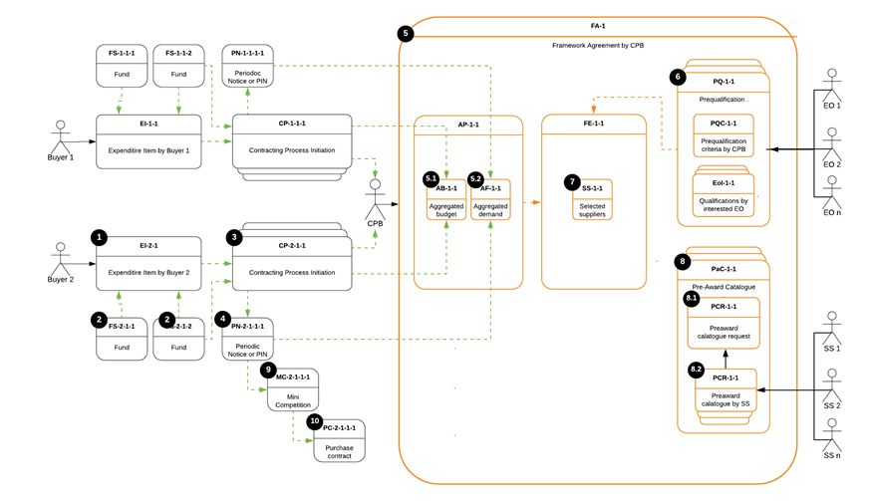

Figure 1 - Basic diagram of a closed FA with the participation of a CPB[1]

### Main data blocks

|  |  |  |
| --- | --- | --- |
| **Data block** | **Acronym** | **Description** |
| Expenditure Item | EI | Describes a group of goods, services or works determined by specifying the parent CPV code that the PE intends to procure over a certain period, as well as the amount allocated by the PE to finance the purchases under this procurement procedure during the specified period. |
| Funding Source | FS | Describes a specific source of funds for the need from a primary EI. Contains information on both the amount and the organization that provides the funds, as well as on the parties involved in the disposal of these funds such as payer/donor. |
| Contracting Process | CP | Describes a process, so it does not match with an OCDS block. However, it is needed in the FA data model in order to store all the planning and tender information, and its relationship with other processes. |
| Periodic Notice | PN | Describes an announcement of the PE’s intention to conduct a procurement procedure (Aggregation demand notice). |
| Aggregated Plan | AP | Describes both aggregated demand and budget as per CPB analysis. |
| Framework Agreement | FA | Describes a specific instance of a FA initiated by a CPB. |
| Framework Establishment | FE | Describes the conclusion of a FA. |
| Aggregated Budget | AB | Describes the aggregated budget and its breakdown from all the PE, from which planned and requested demand is aggregated within this FA. |
| Aggregated Forecast | AF | Describes an aggregate forecast and its breakdown from all the PE, from which planned and requested demand is aggregated within this FA |
| Pre-qualification | PQ | Describes the pre-qualification phase(s) performed by the CPB for the conclusion of this FA. |
| Pre-qualification Criteria | PQC | Describes a set of exclusion grounds and selection criteria, together with a scoring function (if applicable), as per CPBs' strategy. |
| Expression of Interest | EoI | Describes an interest expressed by a supplier via submission of self-declaration to be qualified by the CPB. |
| Selected Suppliers | SS | Describes a list of suppliers qualified by the CPB and included into this FA as parties. |
| Pre-award Catalogue Request | PCR | Describes a structured request for electronic catalogue with specific categories of goods or services for this FA provided by the CPB to the selected suppliers. |
| Pre-award Catalogue | PAC | Describes a structured electronic catalogue with specific categories of goods or services for this FA and the relevant indicative prices received from selected suppliers. |
| Mini-competition / Second-stage competition | MC | Describes a simplified competitive procurement process by the PE under a FA. |
| Purchase Order | PO | Describes a structured request of a specific purchase by the PE sent to one or several suppliers of this FA. |
| Purchase Contract | PC | Describes a contract concluded within this FA via one of the applicable methods allowed under the execution of a FA. |

Table 1 – Main data blocks involved in a FA

### Main actors

|  |  |  |
| --- | --- | --- |
| **Actor** | **Acronym** | **Description** |
| Buyer | n/a | A PE, party of the FA, whose demand and budget are aggregated and included by a CPB into the FA. |
| Central Purchasing Body | CPB | PE providing centralised purchasing activities, responsible for the FA. |
| Supplier | n/a | Any tenderer interested in participating in the FA. |
| Selected Supplier | SS | Supplier qualified by the CPB during the pre-qualification phase |

Table 2 – Main actors involved in a FA

### Data flow

Taking as a reference the diagram from section 2.1 (Figure 1), the table below shows the example of the use-case of Buyer 2:

|  |  |  |
| --- | --- | --- |
| **From** | **To** | **Description** |
| - | EI-2-1 | A specific need is identified (aggregated and weighted) and described by the PE (Buyer 2). |
| - | FS-2-1-n | Funds are identified and described. Linkages with target EI are established. |
| EI-2-1 | CP-2-1-1 | A procurement process for this EI (or a part of it) is initiated and specific Funding Sources (FS) enough to cover the assumed value of the contract are allocated from the FSs available for this parent EI. |
| CP-2-1-1 | PN-2-1-1-1 | The procurement process is initially planned: the forecast and assumed value are described, and a delivery deadline is indicated. |
| CP-2-1-1 | CPB | The PE provides all the information to the CPB, who will work with the aggregated demand and budget and will be responsible of the conclusion of the FA. |
| PN-2-1-1-1 | AF-1-1 | Procurement forecast described in the Periodic Notice (PN) is sent to be aggregated with the forecasts of other PEs by the CPB. |
| CP-2-1-1 | AB-1-1 | A budget breakdown described for this procurement process is sent to be aggregated with others by the CPB. |
| FA-1 | PQ-1-1 | A Pre-qualification round is initiated under this FA in order to select relevant (qualified) suppliers. Only those suppliers that qualify (this is, that provide valid evidence to all qualification requirements) will be admitted in the procedure. Suppliers that do not qualified are discarded and, depending on the procurement procedure, their bids will remain unopened and will not be evaluated, or they will not be invited to submit a bid. |
| PQ-1-1 | PQC-1-1 | A set of pre-qualification criteria is specified by the CPB in the CN under this pre-qualification round. |
| EO-n | EoI-1-n | Expressions of interest (EoI) are submitted by suppliers within this pre-qualification round. |
| PQ-1-1 | SS-1-1 | The suppliers to be invited to submit an offer are selected in this pre-qualification round (only in the case of a two-stage procedure such as restricted procedure). |
| FA-1 | PaC-1-1 | A Pre-Award Catalogue (PAC) with the specific services or goods to be purchased is issued by the CPB. |
| PaC-1-1 | PCR-1-1 | A Pre-award Catalogue Request (PCR) with the specific services or goods to be purchased is sent by the CPB to the selected suppliers. |
| SS-n | PCR-1-n | A PAC response is received from suppliers in response to the CPBs' PCR. |
| PaC-1-1 | MC-2-1-1-1 | A second-stage competition procedure between those suppliers that have been selected to be party of the FA is initiated by the PE (Buyer 2) under this FA in order to cover parent EI or a part of it. |
| MC-2-1-1-1 | PC-2-1-1-1 | A Purchase Contract (PC) is concluded between the PE (Buyer 2) and the supplier winner of the second-stage competition. |

Table 3 – Example of a use case

## BPMN

### Conclusion of a closed Framework Agreement

The diagram below shows the general process for the conclusion of a closed FA:

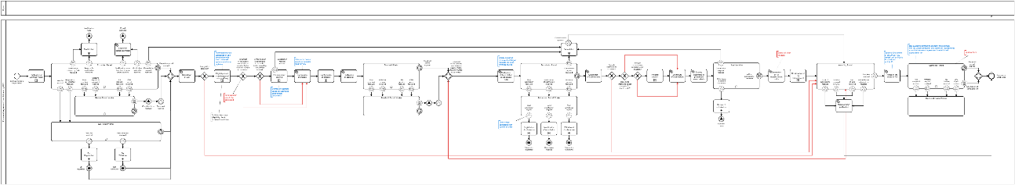

Figure 2 – BPMN for the general process of a FA[2]

### Execution of a closed Framework Agreement

The diagram below shows the general processes for the execution of a closed FA with the different types of contracts based on a FA:

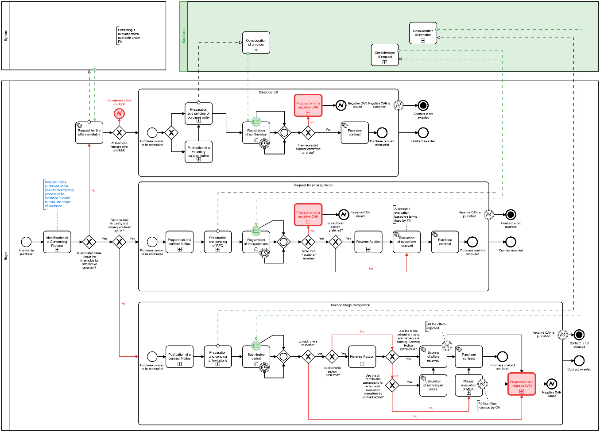

Figure 3 – BPMN for the execution of a closed FA[3]

## OCDS design

The diagram below shows the general data-set of a closed FA, which is a quite comprehensive and complex structure of the related transactional data which involves more than 10 parallel data-streams in its lifecycle:

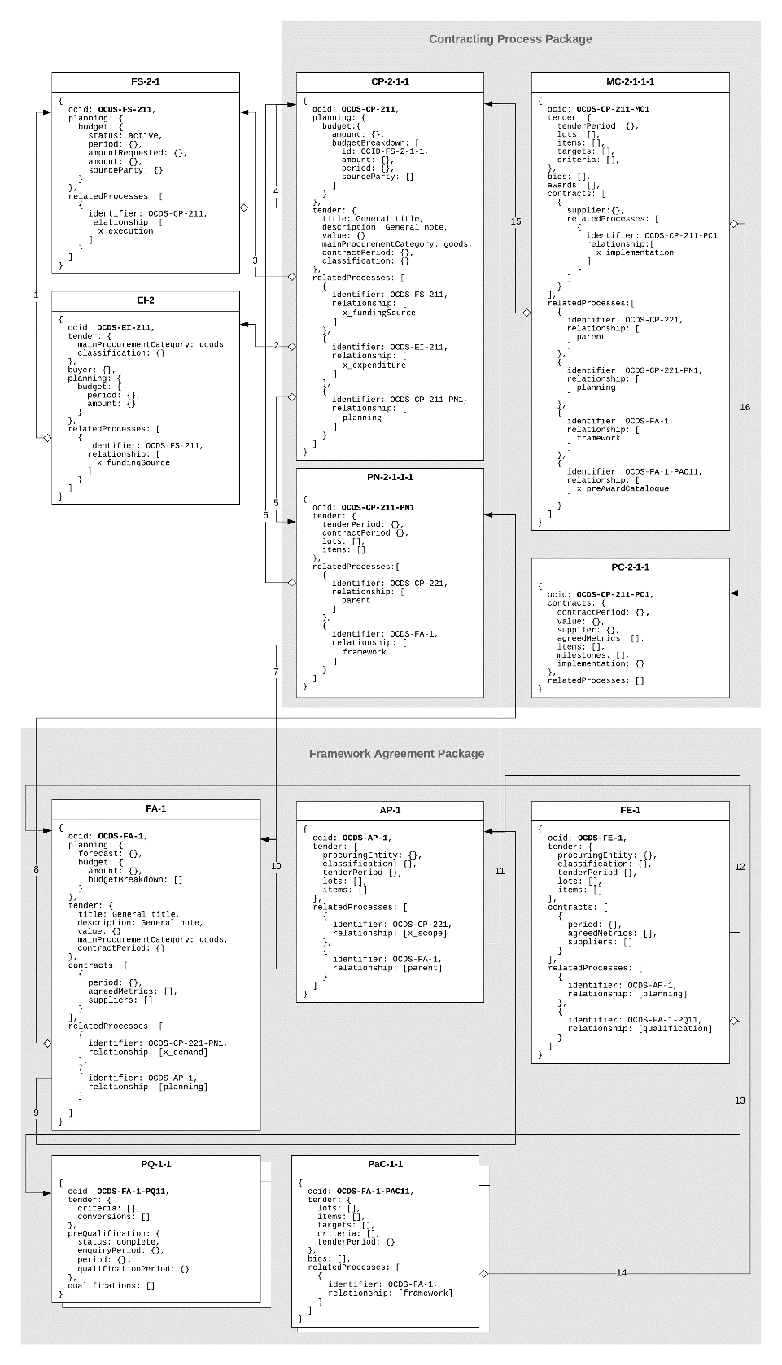

Figure 4 – OCDS design for a FA

### Map of relations

|  |  |  |  |
| --- | --- | --- | --- |
| **№** | **Description** | **Code** | **Precondition** |
| 1 | FS as a funds related source to EI | x_fundingSource | Funds associated by a PE with a specific need |
| 2 | EI as to related class of need to CP | x_expenditureItem | A procurement process is initiated by a PE based on a specific classified need |
| 3 | FS as allocated funds source to CP | x_fundingSource | Funds allocated by a PE to cover a future contract (or a part of it) |
| 4 | CP as a subsidized stream to FS | x_execution | Funds approved to cover a future contract (or a part of it) |
| 5 | PN as a planning phase to CP | planning | Procurement plan regarding a specific procurement process |
| 6 | CP as a parent to a PN | parent | Planning phase is started for this procurement process |
| 7 | FA as a related framework to PN | framework | FA indicated by a PE for further aggregation |
| 8 | PN as a demand requested to be included to FA | x_demand | Planned demand is requested by a PE to be included into the scope of a FA managed by a CPB |
| 9 | AP as a planning phase to FA | planning | Aggregated demand for a specific FA |
| 10 | FA as a parent to a AP | parent | Aggregated planning is started for this FA |
| 11 | PN as an aggregated scope to AP | x_scope | A request for participation is approved by the CPB, and therefore the PE' demand is aggregated to the FA |
| 12 | AP as an indicative forecast to FE | planning | FA if initiated by the CPB based on an aggregated plan for this FA |
| 13 | PQ as a pre-qualification phase to FE | qualification | Pre-qualification phase is started for this FA |
| 14 | FA as a managing framework to PaC | framework | PCR is issued by the CPB and send to selected suppliers |
| 15 | CP as a parent to MC | parent | FA execution is initiated under a specific procurement process aggregated by this FA |
| 16 | PC as implementation to MC | x_execution | Purchase contract is concluded under a FA with a specific procurement process |

Table 4 – Map of relations

### OCDS parallel records used to reflect OCDS design for FAs

##### EI

|  |  |  |
| --- | --- | --- |
| **Attribute** | **Description** | **Covered by** |
| Ocid | Global unique identifier for this EI | [OCDS 1.1](https://standard.open-contracting.org/latest/en/schema/identifiers/) |
| tender.mainProcurementCategory | Category of the subject of this EI | [OCDS 1.1](https://standard.open-contracting.org/latest/en/schema/codelists/#procurement-category) |
| tender.classification | CPV classification of the subject of this EI | Not covered |
| Buyer | Organization in whose interests the need is declared | [OCDS 1.1.](https://standard.open-contracting.org/latest/en/schema/reference/#release) |
| planning.budget.period | The aggregated period of availability of funding sources under this EI | [core_extension](https://github.com/open-contracting-extensions/ocds_budget_breakdown_extension/blob/master/release-schema.json) |
| planning.budget.amount | The absolute total value of all the funding sources under this EI | [core_extension](https://github.com/open-contracting-extensions/ocds_budget_breakdown_extension/blob/master/release-schema.json) |
| relatedProcesses | The link to the funding sources allocated for this EI | [OCDS 1.1](https://standard.open-contracting.org/latest/en/schema/reference/?highlight=relatedProcess#relatedprocess) |

Table 5 – Attributes of EI

##### FS

|  |  |  |
| --- | --- | --- |
| **Attribute** | **Description** | **Covered by** |
| Ocid | Global unique identifier for this FS | [OCDS 1.1](https://standard.open-contracting.org/latest/en/schema/identifiers/) |
| planning.budget.period | The period of availability of this FS | [core_extension](https://github.com/open-contracting-extensions/ocds_budget_breakdown_extension/blob/master/release-schema.json) |
| planning.budget.amount | The absolute value of this FS | [core_extension](https://github.com/open-contracting-extensions/ocds_budget_breakdown_extension/blob/master/release-schema.json) |
| planning.budget.amountRequested | Future steps of representing the workflow of budget approvals | [Issue #616](https://github.com/open-contracting/standard/issues/616) |
| planning.budget.status | Future steps of representing the workflow of budget approvals | [Issue #616](https://github.com/open-contracting/standard/issues/616) |
| planning.budget.sourceParty | The organization related to this FS | [core_extension](https://github.com/open-contracting-extensions/ocds_budget_breakdown_extension/blob/master/release-schema.json) |
| relatedProcesses | The link to an EI this FS is related to | [OCDS 1.1](https://standard.open-contracting.org/latest/en/schema/reference/?highlight=relatedProcess#relatedprocess) |

Table 6 – Attributes of FS

##### CP

|  |  |  |
| --- | --- | --- |
| **Attribute** | **Description** | **Covered by** |
| ocid | Global unique identifier for this procurement process | [OCDS 1.1](https://standard.open-contracting.org/latest/en/schema/identifiers/) |
| planning.budget.amount | The overall value of the funds allocated for this procurement process | [core_extension](https://github.com/open-contracting-extensions/ocds_budget_breakdown_extension/blob/master/release-schema.json) |
| planning.budget.budgetBreakdown | Detailed budget breakdown under this procurement process, covering multiple budget funding and multiple periods | [core_extension](https://github.com/open-contracting-extensions/ocds_budget_breakdown_extension/blob/master/release-schema.json) |
| tender.title | An overall title for this procurement process | [OCDS 1.1.](https://standard.open-contracting.org/latest/en/schema/reference/#release) |
| tender.description | An overall description for this procurement process | [OCDS 1.1.](https://standard.open-contracting.org/latest/en/schema/reference/#release) |
| tender.value | The total upper estimated value of the procurement process | [OCDS 1.1.](https://standard.open-contracting.org/latest/en/schema/reference/#release) |
| tender.mainProcurementCategory | Category of the subject of this procurement process | [OCDS 1.1](https://standard.open-contracting.org/latest/en/schema/codelists/#procurement-category) |
| tender.classification | CPV classification of the subject of this procurement process | Not covered |
| buyer | Organization in whose interests the need is declared | [OCDS 1.1.](https://standard.open-contracting.org/latest/en/schema/reference/#release) |
| tender.contractPeriod | The period over which the contract is estimated or required to be active | [OCDS 1.1](https://standard.open-contracting.org/latest/en/schema/reference/#tender) |
| relatedProcesses | Parallel processes related to a current one | [OCDS 1.1](https://standard.open-contracting.org/latest/en/schema/reference/#tender) |
| *.relationship: x_fundingSource | Link to related FS(s) | [OCDS 1.1](https://standard.open-contracting.org/latest/en/schema/reference/?highlight=relatedProcess#relatedprocess) |
| *.relationship: x_expenditure | Link to related EI(s) | [OCDS 1.1](https://standard.open-contracting.org/latest/en/schema/reference/?highlight=relatedProcess#relatedprocess) |
| *.relationship: planning | Link to related PN | [OCDS 1.1](https://standard.open-contracting.org/latest/en/schema/reference/?highlight=relatedProcess#relatedprocess) |
| *.relationship: x_framework | Link to related FA (when subject is included in a FA) | [OCDS 1.1](https://standard.open-contracting.org/latest/en/schema/reference/?highlight=relatedProcess#relatedprocess) |

Table 7 – Attributes of CP

##### PN

|  |  |  |
| --- | --- | --- |
| **Attribute** | **Description** | **Covered by** |
| Ocid | Global unique identifier for the PN under this procurement process | [OCDS 1.1](https://standard.open-contracting.org/latest/en/schema/reference/#release) |
| tender.tenderPeriod | Indicative date (month or quarter) of call for proposals under this procurement process | [OCDS 1.1](https://standard.open-contracting.org/latest/en/schema/reference/#tender) |
| tender.contractPeriod | Expected contract period for a contract concluded under this procurement process | [OCDS 1.1](https://standard.open-contracting.org/latest/en/schema/reference/#tender) |
| tender.lots | Provisional division into lots | [core_extension](https://github.com/open-contracting-extensions/ocds_lots_extension) |
| tender.items | Provisional nomenclature of a subject of procurement | [OCDS 1.1](https://standard.open-contracting.org/latest/en/schema/reference/#tender) |
| relatedProcesses | Link to the parent procurement process | [OCDS 1.1](https://standard.open-contracting.org/latest/en/schema/reference/?highlight=relatedProcess#relatedprocess) |

Table 8 – Attributes of PN

##### MC

|  |  |  |
| --- | --- | --- |
| **Attribute** | **Description** | **Covered by** |
| Ocid | Global unique identifier for the MC or second-stage competition under this procurement process | [OCDS 1.1](https://standard.open-contracting.org/latest/en/schema/reference/#release) |
| tender.tenderPeriod | Period for submitting bids in this MC | [OCDS 1.1](https://standard.open-contracting.org/latest/en/schema/reference/#tender) |
| tender.lots | Lots of this MC | [core_extension](https://github.com/open-contracting-extensions/ocds_lots_extension) |
| tender.items | Nomenclature of this MC | [OCDS 1.1](https://standard.open-contracting.org/latest/en/schema/reference/#tender) |
| tender.criteria | Any evaluation criteria applied for this MC | [core_extension](https://github.com/open-contracting-extensions/ocds_requirements_extension) |
| tender.targets | Any indicative metrics criteria applied for this MC | [core_extension](https://github.com/open-contracting-extensions/ocds_metrics_extension) |
| Bids | List of tenders collected under this MC | [core_extension](https://github.com/open-contracting-extensions/ocds_bid_extension) |
| Awards | Award-decision taken under this MC | [OCDS 1.1](https://standard.open-contracting.org/latest/en/schema/reference/#tender) |
| contracts[*].supplier | List of suppliers awarded under this MC | [OCDS 1.1](https://standard.open-contracting.org/latest/en/schema/reference/#tender) |
| contract[*].AwardID | Reference on award for purchase contract concluded under this MC | [OCDS 1.1](https://standard.open-contracting.org/latest/en/schema/reference/#tender) |
| relatedProcesses | Parallel processes related to a current one | [OCDS 1.1](https://standard.open-contracting.org/latest/en/schema/reference/?highlight=relatedProcess#relatedprocess) |
| *.relationship: parent | Link to a procurement process | [OCDS 1.1](https://standard.open-contracting.org/latest/en/schema/reference/?highlight=relatedProcess#relatedprocess) |
| *.relationship: planning | Link to PN | [OCDS 1.1](https://standard.open-contracting.org/latest/en/schema/reference/?highlight=relatedProcess#relatedprocess) |
| *.relationship: framework | Link to FA | [OCDS 1.1](https://standard.open-contracting.org/latest/en/schema/reference/?highlight=relatedProcess#relatedprocess) |
| *.relationship: x_preAwardCatalogue | Link to PCR | [OCDS 1.1](https://standard.open-contracting.org/latest/en/schema/reference/?highlight=relatedProcess#relatedprocess) |

Table 9 – Attributes of MC

##### PC

|  |  |  |
| --- | --- | --- |
| **Attribute** | **Description** | **Covered by** |
| Ocid | Global unique identifier for the PC under this procurement process | [OCDS 1.1](https://standard.open-contracting.org/latest/en/schema/reference/#release) |
| contracts[*].contractPeriod | A period for this PC | [OCDS.1.1](https://standard.open-contracting.org/latest/en/schema/reference/#contract) |
| contracts[*].supplier | The supplier winner of this PC | [OCDS.1.1](https://standard.open-contracting.org/latest/en/schema/reference/#contract) |
| contracts[*].value | The value of this PC | [OCDS.1.1](https://standard.open-contracting.org/latest/en/schema/reference/#contract) |
| contracts[*].agreedMetrics | The metrics agreed under this PC | [core_extension](https://github.com/open-contracting-extensions/ocds_metrics_extension) |
| contracts[*].items | A scope of performance under this PC | [OCDS.1.1](https://standard.open-contracting.org/latest/en/schema/reference/#contract) |
| contracts[*].milestones | The milestones of this PC | [OCDS.1.1](https://standard.open-contracting.org/latest/en/schema/reference/#contract) |
| contracts[*].implementation | An implementation record under this PC | [OCDS.1.1](https://standard.open-contracting.org/latest/en/schema/reference/#contract) |

Table 10 – Attributes of PC

##### FA

|  |  |  |
| --- | --- | --- |
| **Attribute** | **Description** | **Covered by** |
| Ocid | Global unique identifier for this FA | [OCDS 1.1](https://standard.open-contracting.org/latest/en/schema/reference/?highlight=relatedProcess#relatedprocess) |
| planning.forecast | The indicative scope of this FA | [core_extension](https://github.com/open-contracting-extensions/ocds_metrics_extension) |
| tender.title | Title for the FA | [OCDS 1.1](https://standard.open-contracting.org/latest/en/schema/reference/?highlight=relatedProcess#relatedprocess) |
| tender.description | Description for the FA | [OCDS 1.1](https://standard.open-contracting.org/latest/en/schema/reference/?highlight=relatedProcess#relatedprocess) |
| tender.value | Indicative value of this FA | [OCDS 1.1](https://standard.open-contracting.org/latest/en/schema/reference/?highlight=relatedProcess#relatedprocess) |
| tender.mainProcurementCategory | Main procurement category of this FA | [OCDS 1.1](https://standard.open-contracting.org/latest/en/schema/reference/?highlight=relatedProcess#relatedprocess) |
| tender.contractPeriod | Indicative duration of this FA | [OCDS 1.1](https://standard.open-contracting.org/latest/en/schema/reference/?highlight=relatedProcess#relatedprocess) |
| Contracts | List of PCs concluded under this FA | [OCDS 1.1](https://standard.open-contracting.org/latest/en/schema/reference/?highlight=relatedProcess#relatedprocess) |
| relatedProcesses | List of parallel processes related to this FA | [OCDS 1.1](https://standard.open-contracting.org/latest/en/schema/reference/?highlight=relatedProcess#relatedprocess) |
| *.relationship: x_demand | Link to PNs | [OCDS 1.1](https://standard.open-contracting.org/latest/en/schema/reference/?highlight=relatedProcess#relatedprocess) |
| *.relationship: planning | Link to AP | [OCDS 1.1](https://standard.open-contracting.org/latest/en/schema/reference/?highlight=relatedProcess#relatedprocess) |

Table 11 – Attributes of FA

##### AP

|  |  |  |
| --- | --- | --- |
| **Attribute** | **Description** | **Covered by** |
| ocid | Global unique identifier for the AP under this FA | [OCDS 1.1](https://standard.open-contracting.org/latest/en/schema/reference/?highlight=relatedProcess#relatedprocess) |
| tender.classification | Classification of this AP according to CPV | [OCDS 1.1](https://standard.open-contracting.org/latest/en/schema/reference/?highlight=relatedProcess#relatedprocess) |
| tender.tenderPeriod | Indicative start date for the conclusion of the FA | [OCDS 1.1](https://standard.open-contracting.org/latest/en/schema/reference/?highlight=relatedProcess#relatedprocess) |
| tender.items | Nomenclature of this AP | [OCDS 1.1](https://standard.open-contracting.org/latest/en/schema/reference/?highlight=relatedProcess#relatedprocess) |
| tender.lots | Lots this AP is divided into | [core_extension](https://github.com/open-contracting-extensions/ocds_lots_extension) |
| relatedProcesses | Parallel processes related to this AP | [OCDS 1.1](https://standard.open-contracting.org/latest/en/schema/reference/?highlight=relatedProcess#relatedprocess) |
| *.relationship: x_scope | Link to PNs | [OCDS 1.1](https://standard.open-contracting.org/latest/en/schema/reference/?highlight=relatedProcess#relatedprocess) |
| *.relationship: parent | Link to FA | [OCDS 1.1](https://standard.open-contracting.org/latest/en/schema/reference/?highlight=relatedProcess#relatedprocess) |

Table 12 – Attributes of AP

##### FE

|  |  |  |
| --- | --- | --- |
| **Attribute** | **Description** | **Covered by** |
| ocid | Global unique identifier for the FE under this FA | [OCDS 1.1](https://standard.open-contracting.org/latest/en/schema/reference/?highlight=relatedProcess#relatedprocess) |
| tender.procuringEntity | PE in this FA | [OCDS 1.1](https://standard.open-contracting.org/latest/en/schema/reference/?highlight=relatedProcess#relatedprocess) |
| tender.classification | Classification of this FA according to CPV | [OCDS 1.1](https://standard.open-contracting.org/latest/en/schema/reference/?highlight=relatedProcess#relatedprocess) |
| relatedProcesses | Parallel processes related to this FE | [OCDS 1.1](https://standard.open-contracting.org/latest/en/schema/reference/?highlight=relatedProcess#relatedprocess) |
| *.relationship: planning | Link to AP | [OCDS 1.1](https://standard.open-contracting.org/latest/en/schema/reference/?highlight=relatedProcess#relatedprocess) |
| *.relationship: qualification | Link to PQ | [OCDS 1.1](https://standard.open-contracting.org/latest/en/schema/reference/?highlight=relatedProcess#relatedprocess) |

Table 13 – Attributes of FE

##### PQ

|  |  |  |
| --- | --- | --- |
| **Attribute** | **Description** | **Covered by** |
| ocid | Global unique identifier for the PQ under this FA | [OCDS 1.1](https://standard.open-contracting.org/latest/en/schema/reference/?highlight=relatedProcess#relatedprocess) |
| preQualification.enquiryPeriod | Enquiry period allocated under this PQ | [core_extension](https://github.com/open-contracting-extensions/ocds_qualification_extension) |
| preQualification.period | Period for submission of EoIs | [core_extension](https://github.com/open-contracting-extensions/ocds_qualification_extension) |
| preQualification.qualificationPeriod | Period for consideration of EoIs collected by the PE | [core_extension](https://github.com/open-contracting-extensions/ocds_qualification_extension) |
| submissions | EoIs by interested suppliers | Not covered |
| qualifications | Qualification decisions by the PE against received EoI | Not covered |

Table 14 – Attributes of PQ

##### PQC

|  |  |  |
| --- | --- | --- |
| **Attribute** | **Description** | **Covered by** |
| tender.criteria | Any qualification and/or evaluation criteria applied by the PE | [core_extension](https://github.com/open-contracting-extensions/ocds_requirements_extension) |
| tender.conversions | Any weighting related to applied criteria | Not covered |
| tender.otherCriteria | Detailed information about any other requirements or techniques used by the PE | [core_extension](https://github.com/open-contracting-extensions/ocds_otherRequirements_extension) |

Table 15 – Attributes of PQC

##### PAC

|  |  |  |
| --- | --- | --- |
| **Attribute** | **Description** | **Covered by** |
| ocid | Global unique identifier for the PAC under this FA | [OCDS 1.1](https://standard.open-contracting.org/latest/en/schema/reference/?highlight=relatedProcess#relatedprocess) |
| tender.items | Nomenclature requested by the PE within PCR | [OCDS 1.1](https://standard.open-contracting.org/latest/en/schema/reference/?highlight=relatedProcess#relatedprocess) |
| tender.targets | Any targets indicated by the PE within PCR | [core_extension](https://github.com/open-contracting-extensions/ocds_metrics_extension) |
| tender.criteria | Evaluation criteria related to a nomenclature requested by this PCR | [core_extension](https://github.com/open-contracting-extensions/ocds_requirements_extension) |
| tender.tenderPeriod | Period for submission of PACs by invited suppliers | [OCDS 1.1](https://standard.open-contracting.org/latest/en/schema/reference/?highlight=relatedProcess#relatedprocess) |
| bids | PACs submitted by invited suppliers | [core_extension](https://github.com/open-contracting-extensions/ocds_bid_extension) |
| relatedProcesses | Parallel processes related to this PAC | [OCDS 1.1](https://standard.open-contracting.org/latest/en/schema/reference/?highlight=relatedProcess#relatedprocess) |
| *.relationship: framework | Link to FA | [OCDS 1.1](https://standard.open-contracting.org/latest/en/schema/reference/?highlight=relatedProcess#relatedprocess) |

Table 16 – Attributes of PAC

## Conclusion of a closed FA

### OCDS blocks involved in the conclusion of a closed FA

All the aforementioned blocks are involved in the entire FA lifecycle. However, regarding the conclusion of a closed FA, only several are involved:

|  |  |
| --- | --- |
| **Block** | **Description** |
| FA | Describes a specific instance of a FA initiated by a CPB. |
| AP | Describes aggregate demand as per CPB analysis. |
| FE | Describes the conclusion of the FA. |
| PAC | Describes a structured electronic catalogue with specific categories of goods or services for a FA, as well as the relevant indicative prices received from selected suppliers (in the case of request of electronic catalogues to the selected suppliers) |

Table 17 - OCDS blocks involved in the conclusion of a FA

### Building components involved in the conclusion of a closed FA

The following building components are relevant for the conclusion of a closed FA:

* Initiation of a FA: Offline process conducted by the CPB. It is based on the analysis of PEs’ demands described through the lists of EIs as a part of their budgeting process. Having all the needs described by the PEs that want to be party of the FA, the CPB can determine the global needs and specificities of the FA (overall value, geographical distribution, timings, etc.). The main goal of this stage is to decide on the procurement strategy for the conclusion of the FA and inform the PEs;
* Aggregated planning: It contains information about multiple individual procurement plans. Through the aggregation of demand, CPBs are able to significantly diminish costs and get better value for money through economies of scale, although procurement techniques that involve aggregation, such as FA, usually take longer to award than non-aggregated procurement processes;
* Design of a FA: Based on the procurement strategy adopted by the CPB, the relevant aspects regarding the conclusion and execution of the FA are defined in order to initiate the FA process;
* Conclusion of a closed FA: FAs are frequently set by CPBs, which can either act on their own behalf or on behalf of a number of PEs. The successful tenderers are usually selected using open or restricted procedures (although negotiated procedures can also be used when the appropriate conditions are met). The FA determines the method in which specific contracts based on the FA will be awarded to selected suppliers, as well as the terms applying to these awards for a certain period of time;
* Pre-award catalogue request: The PAC provides a list and high-level information and requirements on the goods or services included within the FA, in order for the suppliers to be able to decide whether they have the capacity and are interested or not in being party of the FA. A PAC request does not contain any vendor-specific data.

##### Initiation of a FA

The diagram below shows the processes for the initiation of a FA:

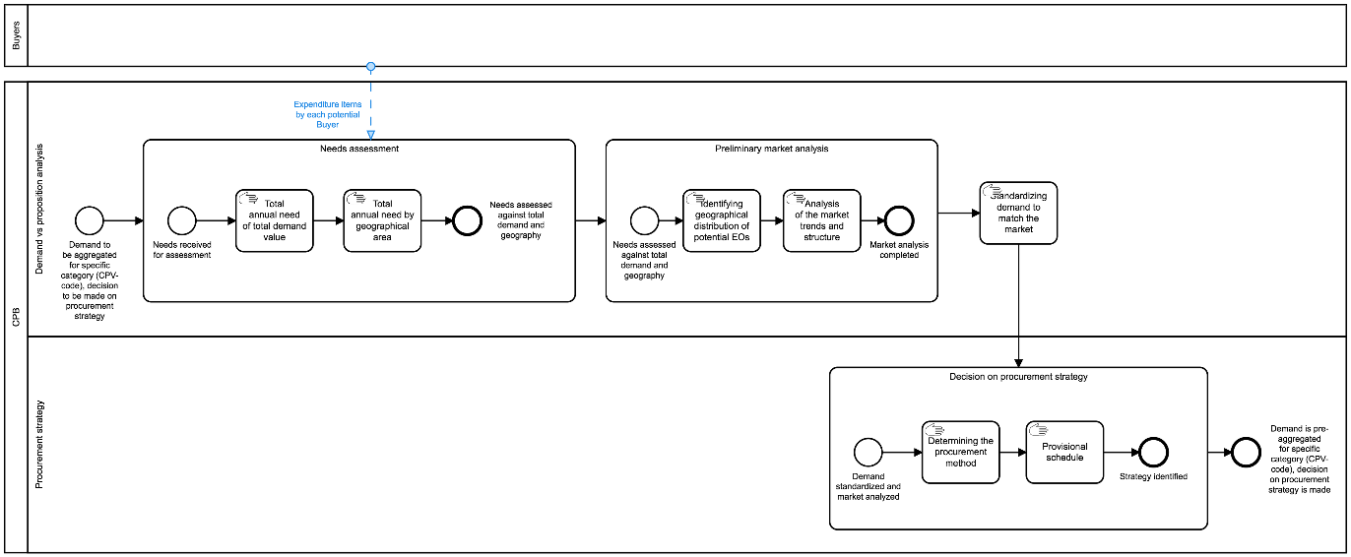

Figure 5 - BPMN for initiation of a FA[4]

All actions regarding aggregation of demand and budget are described in the following section.

##### Aggregated planning

##### BPMN

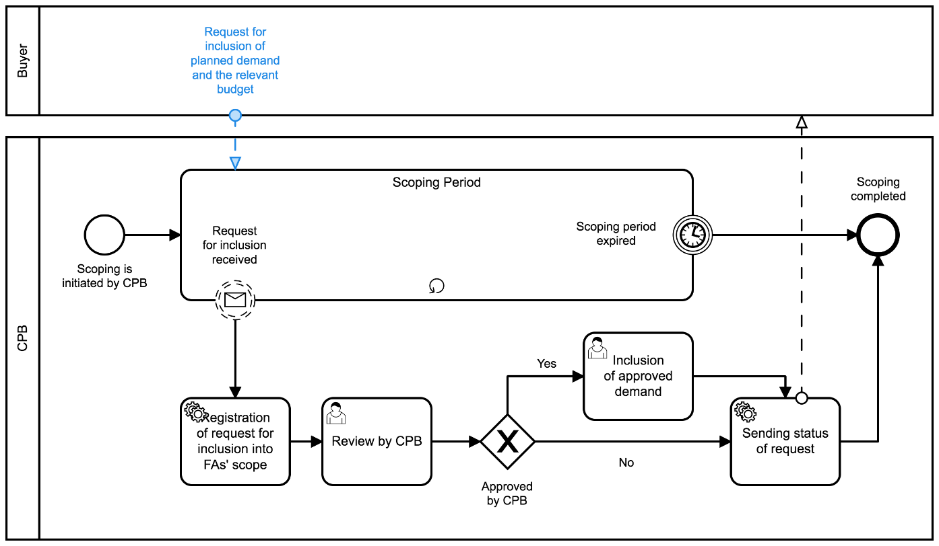

Figure 6 - BPMN for aggregated planning[5]

##### Component diagram

On a data level, aggregation means setting up a relationship between different data-sets and inheritance of specific data in order to reflect aggregation and its scope. The logic illustrated in the following component diagram consists of a sequence of relations of sets based on the business process performed:

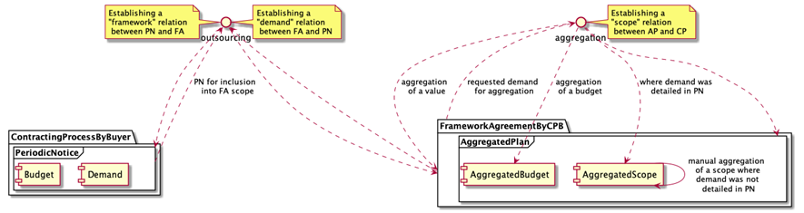

Figure 7 – Component diagram for aggregated planning

According to the business process above, once a PE becomes aware of the intention of a CPB to conduct a FA for a specific category of goods or services, the PE can request the CPB the inclusion of the PE’s demand and related budget into the scope of the FA. In order to do so, the PE needs to describe the demand first by initiating a procurement process (although not a procurement procedure, which will be initiated later on once the FA is concluded and the PE wants to conduct a purchase under this FA) against previously declared annual needs (EI classified with a certain CPV code) and publication of a relevant PN (the aggregation demand notice) describing the provisional schedule, budget allocated, etc. Once these data is provided by the PE, a relation between the PN and the FA can be established. Such a relation serves as a data-hook of inclusion requests recorded.

On the CPB side, each request for inclusion from a PE has to be reviewed by the CPB, who will decide on whether this request is a subject of this FA from classification, geography, volume, etc. perspectives. If it is compliant and the CPB decides to include this demand into the scope of the future FA, such demand is aggregated through establishing a relation between the PN and the aggregated plan.

The CPB proceeds in the same way with all the requests collected during a certain period of time and, having the final aggregated scope, the CPB can complete the scoping period and start designing the FA and preparing the pre-qualification phase.

|  |
| --- |
| Since aggregation of a subject of procurement from multiple sources (PNs by PEs) into a single common scope (AP) doesn't seem a linear process and often requires human analysis, at this stage subject aggregation, together with “lots” strategy, is conducted by the CPB as a manual process. |

##### Design of a FA

##### Determining categories and products

FAs are usually used for repeating needs and enable PEs to manage procurement when they cannot objectively foresee the exact type and/or amount of supplies, services and works for the duration of a given period.

During the design of the FA, the categories and products that will be purchased under this FA must be defined, as well as the possibility of substitution and to what extent. However, when certain terms and conditions of the procurement cannot be established with sufficient precision in the conclusion of the FA, the PE will be able to establish or refine them through second-stage competition processes under the FA.

Technically, determining product categories is the determination of a relevant list of items with aggregated classification according to CPV and decomposed place of performance (delivery).

Find below the simplest case, when the only category of goods scoped for relatively same (or even same) geography:

|  |
| --- |
| {  "tender": {  "items": [  {  "id": "001",  "description": "Notebooks",  "quantity": 200,  "classification": {  "schema": "CPV",  "id": "30213100-6",  "description": "Portable computers"  }  },  "deliveryAddress": {  "region": "Florida"  }  ]  }  } |

Figure 8 – Simplest case

Find below a more complex case when a common volume in a category of goods is divided through geography:

|  |
| --- |
| {  "tender": {  "items": [  {  "id": "001",  "description": "Notebooks",  "quantity": 150,  "classification": {  "schema": "CPV",  "id": "30213100-6",  "description": "Portable computers"  }  },  "deliveryAddress": {  "region": "Florida"  },  {  "id": "002",  "description": "Notebooks",  "quantity": 50,  "classification": {  "schema": "CPV",  "id": "30213100-6",  "description": "Portable computers"  }  },  "deliveryAddress": {  "region": "California"  }  ]  } |

Figure 9 – Complex case

##### Decision on minimum technical specifications

FAs are used for established and repetitive needs when the PE does not know in advance either the exact contract amount and/or exactly when the need will occur. Therefore, FAs allow PEs to set the parameters for purchases without having to define the precise amounts or the full specifications, providing streamlined processes for standardized purchases. Subsequently, contracts based on a closed FA will be conducted only with the suppliers that are party to this FA.

Therefore, two different stages must be considered regarding closed FAs:

1. Conclusion on the FA: In order to conclude a closed FA, PEs can use any of the usual procedures, and open and restricted procedures are usually applied. Consequently, the normal processes and normal rules apply, in particular those concerning publicity, time limits, criteria for exclusion, selection and award. The conclusion of the closed FA ends with the selection of the suppliers that will be party of the FA.
2. Contracts under the FA: Different processes can be conducted for contracts based on FAs, such as direct award, request for quotation and second-stage competition. In closed FAs, only those suppliers party of the FA, that is, that were selected during the conclusion of the FA, can be awarded contracts under this FA.

When a PE deals with a large portfolio of products (for example 10,000 types of office supplies) the question arises, whether all these products must be identified and considered at the award stage in the FA, and to what extent they need to be described. It seems to be reasonable to describe the subject matter in a broad manner since such an approach gives the flexibility needed both when concluding a FA and when using it.

On the other hand, a sort of balance in clarity for both PE and suppliers can be achieved by including a clear, precise and unequivocal review clause in the FA, in which it is predicted that a substitution of products is allowed. Such review clauses shall state the scope and nature of possible modifications or options, as well as the conditions under which they may be used. They shall not provide for modifications or options that would alter the overall nature of the FA. What needs to be considered in drafting the review clauses is, whether the allowed substitution regards a change of a product for a new one, but with the terms of keeping the agreed price, or whether the substitution will allow an upgrade of a product connected with a price increase.

Technically, decisions on minimum technical specification and introduction of relevant review clauses are the determination of a list of targets and criteria for each bunch of such technical specifications expressed with a review clause. targets describe a list of minimum, maximum and expected allowed values or its ranges for the certain attributes of a particular category (item), and criteria is a way on how to requisite suppliers’ offers against prescribed targets:

|  |
| --- |
| {  "tender": {  "items": [  {  "id": "001",  "description": "Simple notebooks",  "quantity": 100,  "classification": {  "schema": "CPV",  "id": "30213100-6",  "description": "Portable computers"  },  "deliveryAddress": {  "region": "Florida"  }  }  ],  "targets": [  {  "id": "001",  "title": "Product metrics",  "description": "Minimum technical requirements",  "relatesTo": "item",  "relatedItem": "001",  "observations": [  {  "id": "001-1",  "note": "Diagonal",  "measure": 15,  "unit": {  "id": "",  "name": "inches"  },  "relatedRequirementID": "001-1-2"  },  {  "id": "001-2",  "note": "HDD Volume",  "measure": 102400,  "unit": {  "id": "",  "name": "Mbyte"  },  "relatedRequirementID": "001-1-4"  }  ]  },  {  "id": "002",  "title": "Estimated maximum budget",  "description": "Exepected maximum unit price",  "relatesTo": "item",  "relatedItem": "001",  "observations": [  {  "id": "002-1",  "note": "Unit price in UAH",  "value": {  "amount": 25000,  "currency": "UAH",  "valueAddedTaxIncluded": true  }  }  ]  }  ],  "criteria": [  {  "id": "007",  "title": "Characteristics",  "relatesTo": "item",  "relatedItem": "001",  "requirementGroups": [  {  "id": "001-1",  "requirements": [  {  "id": "001-1-1",  "title": "Processor family",  "dataType": "string"  },  {  "id": "001-1-2",  "title": "Diagonal",  "dataType": "number",  "minValue": 15  },  {  "id": "001-1-3",  "title": "RAM Volume",  "dataType": "integer"  },  {  "id": "001-1-4",  "title": "HDD Volume",  "dataType": "integer",  "minValue": 102400  }  ]  }  ]  }  ]  }  } |

Figure 10 – Technical specifications

As shown in the example above, criteria in this context can be used not only against metrics prescribed but also in order to describe any other information not covered by any observation, but needed from a requisition perspective.

##### Decision on lots

FAs can be divided into lots. Technically, the decision on lots is a determination of a relevant list of lots with aggregated classification according to CPV.

|  |
| --- |
| {  "tender": {  "lots": [  {  "id": "001",  "status": "active",  "title": "Simple notebooks",  "classification": {  "scheme": "CPV",  "id": "30213100-6",  "description": "Portable computers"  }  },  {  "id": "002",  "status": "active",  "title": "Advanced notebooks",  "classification": {  "scheme": "CPV",  "id": "30213100-6",  "description": "Portable computers"  }  }  ]  }  } |

Figure 11 – Division into lots

##### Determining the characteristics of the FA

##### Fixed and non-fixed terms

When it comes to FAs that do not include all terms and conditions, it will be necessary to establish or refine all non-fixed terms through second-stage competition processes under this FA.

* Information about options regarding additional purchases: A PE may have a right (but not the obligation) to additional purchases from a supplier while the contract is valid. For example, a contract may concern a thousand uniforms, and the PE may have the option to request an additional hundred uniforms. This may be useful when, with the conclusion of the FA, the PE doesn't yet know whether a planned increase in staff will take place.

The options.hasOptions field can be set to true, and the options.description field can describe the options for additional purchases. hasOptions and options.description can also be set on Lot objects in the tender.lots array:

|  |
| --- |
| {  "tender": {  "lots": [  {  "id": "001",  "options": {  "hasOptions": true,  "description": "The buyer has the option to buy an additional hundred uniforms."  }  }  ]  }  } |

Figure 12 – Options for additional purchases

* Information on the recurrence of the procurement process. It indicates that the contract is likely to be re-launched, or re-established, in the foreseeable future. Note that this does not mean awarding multiple contracts within a single FA; in these cases, these fields should not be used. This information can be useful, for example, to suppliers deciding whether to invest or not into machinery necessary for a particular contract since, with this information, they know that there will likely be an opportunity to win similar contracts in future years, which may make the investment more worthwhile.

|  |
| --- |
| {  "tender": {  "lots": [  {  "id": "001",  "options": {  "hasOptions": true,  "description": "The buyer has the option to buy an additional hundred uniforms."  }  }  ]  }  } |

Figure 13 – Recurrence

* Description of the options for the renewal of contracts

|  |
| --- |
| {  "tender": {  "lots": [  {  "id": "001",  "renewals": {  "hasRenewals": true,  "variantsDetails": "Contracts are due to be renewed one time at the end of the initial term"  }  }  ]  }  } |

Figure 14 – Renewals

* Information about variants

|  |
| --- |
| {  "tender": {  "lots": [  {  "id": "001",  "variants": {  "hasVariants": true,  "variantsDetails": "Any relevant items are permitted"  }  }  ]  }  } |

Figure 15 – Variants

##### Duration

The duration of a FA can be defined and shall not exceed the duration established in the regulation.

|  |
| --- |
| {  "tender": {  "lots": [  {  "id": "001",  "contractPeriod": {  "durationInMonth": 36,  "startDate": "",  "endDate": ""  }  }  ]  }  } |

Figure 16 – Duration of the FA

##### Limitations on the number of selected suppliers

When the PE intends to select more than one supplier to be party of a closed FA (multi-supplier closed FA), the minimum number of suppliers must be established in the Contract Notice (CN). There is no limitation on the maximum number of suppliers that can be party of a multi-supplier closed FA, but if the PE wants to establish a maximum, it must be indicated in the CN too. When this is a case, pre-selection instead of pre-qualification will be conducted in order to score all the candidates.

For this phase, qualification requirements are evaluated by the PE based on evidences provided by suppliers. Qualification requirements are divided into[6]:

* Qualification requirements linked to exclusion grounds, with the purpose to determine whether a supplier is allowed to participate in a procurement procedure. These qualification requirements linked to exclusion grounds are pass/fail.
* Qualification requirements not linked to exclusion grounds, which are selection criteria and can be either pass/fail or be weighted. When selection criteria are weighted, it is possible to rank the suppliers that qualify and only those suppliers who have been qualified and/or shortlisted based on the information provided are invited to submit a bid.

Only those suppliers that qualify (this is, that provide valid evidence to all qualification requirements) will be admitted in the procedure. Suppliers that do not qualified are discarded and, depending on the procurement procedure, their bids will remain unopened and will not be evaluated, or they will not be invited to submit a bid.

Qualification requirements are managed by the ESPD through two different files:

* Request, which is generated by the PE during the pre-tendering phase of the procurement process. The PE should able to select those specific qualification requirements (both exclusion grounds and selection criteria) that apply for a given procurement procedure. The Request will be published together with the Contract Notice.
* Response, which is a self-declaration of the businesses' financial status, abilities and suitability for a public procurement procedure. It is generated by the supplier in response to the Request and will be provided together with the supplier’s bid when the tender is submitted, within the tendering phase of the procurement process.

The information that the supplier will be requested to provide in the Response depends on the role of the supplier in this specific procurement procedure:

* If the supplier is a sole contractor (that is, is not participating with others in the procurement procedure), then no information regarding other entities or groups will be required and the supplier will need to produce a complete Response, this is, will be required to provide information for all parts of the Response, in particular for exclusion grounds and selection criteria.
* If the supplier is a lead entity (that is, it is participating with others (as a member of a group, or together with other entities that are not part of a group) in the procurement procedure), then the supplier will need to:
  + In case the supplier is participating in the procurement procedure in a group (Consortium, Joint Venture or others), the supplier will need to provide the name of the group and data about all other members of the group.
  + In case the supplier relies on the capacities of other entities in order to meet the selection criteria, the supplier will need to provide data about all the entities the supplier relies on (name, type of ID, ID and activity for this specific procedure).
  + In case the supplier intends to subcontract any share of the contract to third parties, the supplier will need to provide data about all subcontractors.

In any of the previous cases, when the supplier is a lead entity, it will need to:

* + Produce a complete Response, this is, will be required to provide all information, in particular for exclusion grounds and selection criteria.
  + Provides in his Response information regarding all other suppliers it is participating together with in the procurement procedure.
  + Ensure that all other suppliers it is participating together with in the procurement procedure provide a separate Response.
* If the supplier is a group member, but not the leader of the group (Consortium, Joint Venture or other), then the supplier will need to produce a complete Response (in particular, exclusion grounds and selection criteria) but no information regarding neither the group nor other entities will be required (since this information is provided only by the lead entity).
* If the supplier is an entity the lead supplier relies on in order to meet the selection criteria, then the supplier will need to produce a complete Response (in particular, exclusion grounds and selection criteria) but no information regarding groups or other entities will be required.
* If the supplier is a subcontractor on whose capacity the lead supplier does not rely, then the supplier will not need to produce a complete Response but only a simplified version with the basic information of the supplier and the part regarding exclusion grounds. No information regarding selection criteria will be requested.

To limit the number of selected suppliers, secondStage building block shall be within inside the tender (or even for a given specific lot) as shown below:

* For tender:

|  |
| --- |
| {  "tender": {  "secondStage": {  "minimumCandidates": 2,  "maximumCandidates": 5  }  }  } |

Figure 17 – Limitation on the number of candidates at tender level

* For a specific lot:

|  |
| --- |
| {  "tender": {  "lots": [  {  "secondStage": {  "minimumCandidates": 2,  "maximumCandidates": 5  }  }  ]  }  } |

Figure 18 – Limitation on the number of candidates at lot level

##### Other criteria

Other requirements for participation and terms governing the limitation of the number of candidates to be invited to submit a bid, can be defined using secondStage.

Technically, the definition of other requirements is an indication of a code of a core criterion to be applied for a future limitation of the number of candidates to be invited to submit a bid, as reductionCriteria and the specification of a way of how this criterion to be applied with qualificationSystemMethods:

* reductionCriteria
  + When reductionCriteria: scoring, there is a limitation of a number of candidates to be invited. The values for further qualification for reduction will be scored either automatically or manually (depending on the qualificationSystemMethods), based on the set of relevant requirementResponses received from suppliers in response to the requirements indicated by the PE;
  + when reductionCriteria: none, there is no limit for the number of candidates to be invited to submit a bid.
* qualificationSystemMethods
  + When qualificationSystemMethods: automated, the selection of suppliers will be approached automatically.
  + where qualificationSystemMethods: manual - the selection of suppliers will be approached manually by the PE;

The otherCriteria block is expressed as a separate building block in accordance with: <https://github.com/open-contracting-extensions/ocds_otherRequirements_extension>

|  |
| --- |
| {  "tender": {  "otherCriteria": {  "qualificationSystemMethods": [  "automated"  ],  "reductionCriteria": "scoring"  }  }  } |

Figure 19 – Other criteria

##### Award criteria for each category of products

Award criteria are the criteria that constitute the basis on which the PE selects the best tender and awards a contract. These criteria must be established in advance by the PE and must guarantee fair competition. Contracts can be awarded based on:

* Lowest-price (LP): the contract is awarded to the supplier who offers the lowest price for a compliant tender. The price is the only factor that is taken into consideration when selecting the best compliant tender. Tenders are evaluated using a pass or fail system, and no cost analysis or quality considerations are taken into account;
* Most advantageous tender: criteria other than price are considered when evaluating tenders, such as quality, delivery time, after-sales services, etc. Each criterion is given a relative weighting by the PE which reflects its relative importance. The selection of the most advantageous tender is aimed at identifying the tender that offers best value-for-money.

Technically, the definition of award criteria is an indication of a code of criteria to be applied using awardCriteria and the specification of how this criterion must be applied with awardCriteriaDetails:

##### Award criteria

Awarding criterion is a general indicator on which the award decision will be based:

* Where awardCriteria: priceOnly, only bid.value is to be compared in order to identify the most suitable tender;
* where awardCriteria: costOnly, assumption is that all the tenderers have a same value of an offer. This means that the normalised price needs to be calculated for each tender received, based on an estimated value;
* where awardCriteria: qualityOnly, assumption is that the price doesn't matter and the only valuable part of the tender is the quality, meaning the set of values of criteria, selected by the supplier while submitting a tender. This means that the normalised price needs to be calculated for each tender received, based on '1';
* where awardCriteria: ratedCriteria, assumption is that both price and quality matter. This means that the normalised price needs to be calculated for each tender received based on its value.

##### Award criteria details

Regarding how awarding criteria is to be applied for initial scoring of the tenders received using separate tender.awardCriteriaDetails attribute, the PE prescribes how all the tenders received shall be scored (by the System) for further evaluation:

* Where awardCriteriaDetails: automated, the awarding will be approached automatically based on awardCriteria and a set of relevant requirementResponses received from the tenderers against the requirements applied by the PE;
* where awardCriteriaDetails: manual, the awarding will be approached manually by the PE.

|  |
| --- |
| {  "tender": {  "awardCriteria": "priceOnly",  "awardCriteriaDetails": "automated"  }  } |

Figure 20 – Award criteria

The PE must provide the following information in the CN or contract documents:

* Criteria used for the selection of the most advantageous tender or best bid;
* relative weight of each criterion or descending order of importance of these criteria (when, in the opinion of the PE, weighting is not possible).

##### Criteria and requirements

Award criteria must be:

* Linked to the subject-matter of the procurement procedure;
* aimed at identifying the most advantageous tender and have no other purposes;
* objective and objectively quantifiable.

A separate criteria array can be added into the tender building block according to a criteria schema in order to describe:

* criteria[*].relatesTo: tenderer, qualification criteria and its minimum requirements;
* criteria[*].relatesTo: lot || item, specific requirements related to the subject-matter of the procurement procedure, its delivery/performance;
* criteria[*].relatesTo: procuringEntity, requirements related to the PE (e.g. obligation on declaration of non-conflict of interest) and criteria to be evaluated by a Committee.

|  |
| --- |
| {  "tender": {  "criteria": [  {}  ]  }  } |

Figure 21 – CriteriaWeitghting

The weighting system allows the PE to inform suppliers about the relative importance of each criterion in order for suppliers to better prepare their tenders. At the same time, through the weighting system, the PE minimises the possibilities for arbitrary decisions during the process of evaluation of tenders.

PEs may express the relative weighting of criteria using a range with an «appropriate» maximum spread. This spread must be appropriate in the sense that it cannot be so broad (for example, between 10% and 90%) that it would result in a breach of the transparency principle and that it would not provide any valuable indication to potential tenderers of the actual relative importance that the PE assigns to each criterion used. Also, inappropriate weighting could cause problems when conducting the evaluation of tenders and could mean that the tender offering the best value-for-money would not be selected.

A separate conversions array can be added into tender building block. Conversionsis a tool that allows describing used conversions and its applicable coefficients in order to:

* Describe used conversionsand its applicable coefficients, either as a list of precise values or as a mathematical formula for the calculation of the value of a particular coefficientin this particular case (depending on the value received within requirementResponse related to a specific requirement);
* relate each conversion used (together with coefficients) with used criteria or targets(where applicable);
* include applicable options to used criteria or observations for targets*.*

|  |
| --- |
| {  "tender": {  "conversions": [  {}  ]  }  } |

Figure 22 – Conversions

##### Conclusion of a closed FA

The conclusion of a closed FA is preceded by a needs assessment, a market analysis and an aggregate planning by the CPB, based on the individual needs declared by the PEs party to the FA.

Once these previous stages are fulfilled, it is possible to conduct the process of FA conclusion described in this section.

##### State-chart diagram

The sequence of a stages applicable for the conclusion of a closed FA is the following:

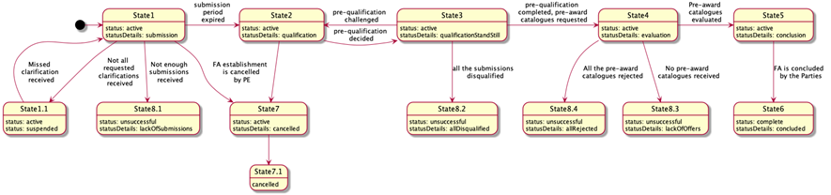

Figure 23 – State-chart diagram for the conclusion of a closed FA

##### OCDS dataset

##### Announcement of the initiation of the FA

The announcement of the initiation of a FA is made through the publication of a CN that provides:

* General procurement information;
* list of products and categories included in the FA;
* minimum technical specifications;
* lots, where applicable;
* fixed and non-fixed terms and conditions;
* duration of the FA;
* limitations on the number of suppliers, where applicable;
* qualification criteria and techniques.

##### Declaration of non-conflict of interest

Officers or employees of PEs must be aware of the code of conduct for the prevention of conflicts of interest in procurement and the measures to regulate issues regarding personnel responsible for procurement. The PE shall exclude a supplier from the procurement proceedings if there is a conflict of interest between parties, for example if the supplier has an unfair competitive advantage or if it offers, gives or agrees to give, directly or indirectly any kind of inducement that may influence in the PE’s decision-making. In case of exclusion, the reasons shall be included in the record of the procurement proceedings and communicated without delay to the concerned supplier.

##### Call for enquiries

In order to indicate the start date and end date of the explanatory phase of a procurement process established by the PE, a separate enquiryPeriod object must be added into the tender building block which will reflect the end date indicated by the PE, and its start date will reflect the moment of initiation of the explanatory phase in the system:

|  |
| --- |
| {  "tender": {  "enquiryPeriod": {  "startDate": "",  "endDate": ""  }  }  } |

Figure 24 – Enquiry period

##### Pre-qualification modality

The pre-qualification phase shall be launched in order to receive requests for participation from interested suppliers. The following options must be taken into consideration:

* Pre-qualification establishment: A separate preQualification block shall be included into the Contract Notice where preliminary qualification or selection of the candidates to be invited to submit an offer is needed.

|  |
| --- |
| {  "preQualification": {  "id": "",  "status": "",  "procuringEntity":{}  }  } |

Figure 25 – PreQualification

* Call for EoI: Submission of EoIs is only available during a certain period determined in the stage of pre-qualification. In order to reflect such a period, a separate object period must be added into the preQualification block.

|  |
| --- |
| {  "preQualification": {  "period": {  "startDate": "",  "endDate": ""  }  }  } |

Figure 26 – Call for EoI

A PAC request can also be published in the situations described in section 2.5.5 of this document.

##### State1 - Submission phase (active.submission)

##### Enquiries - requests and clarifications

During the enquiry period (tender.enquiryPeriod), any interested supplier is allowed to send enquiries, that is, requests for clarification. Such requests remain anonymous until tender.enquiryPeriod.endDate. After tender.enquiryPeriod.endDate, no more enquiries can be received.

* Enquiries: All the enquiries received within the tender.enquiryPeriod must be disclosed immediately as an enquiries array item. Enquiries authors remain confidential until the start of the evaluation.

|  |
| --- |
| {  "tender": {  "enquiries": [  {  "id": "",  "title": "",  "description": "",  "relatedLot": ""  }  ]  }  } |

Figure 27 – Enquiries

* Answers: During enquiryPeriod, the PE is able to submit an answer to each question received.

|  |
| --- |
| {  "tender": {  "enquiries": [  {  "id": ""  "answer": "",  "dateAnswered": ""  }  ]  }  } |

Figure 28 – Answers to enquiries

##### Submission of EoI

The submission of EoIs is only allowed during a specific period of time, determined by a pre-qualification stage. In order to reflect this period, a separate period object can be added into the preQualification block, where the specific timeframe for EoIs is determined. Thus, within a given preQualification.period any interested supplier is allowed to send a submissions, that is, a request for participation or EoI. Each request shall fulfil all the requirements set by the PE, providing an array of requirementResponses.

|  |
| --- |
| Having a set of requirements predefined by the PE and a number of values available for each requirement, suppliers shall specify a value for each requirement and fulfil general corporate profiles’ data as requested by the PE or required by the Legal Framework of a particular jurisdiction. |

Thus, each EoI includes:

1. An organisation profile according to the extended ‘organisation’ model;
2. a set of documents of the tender, specified with relevant types of documents for their future splitting into the different "envelopes";
3. a set of required responses according to criteria specified by the PE within the CN:

* Commitment on exclusion grounds;
* commitment on selection criteria (including absolute values if required);
* commitment on minimum technical requirements (including absolute values if required).

|  |
| --- |
| {  "submission": {  {  "id": "1",  "requirementResponses": [  {  "id": "",  "value": "true",  "requirement": {},  "relatedCandidate": {}  },  {  "id": "",  "value": "true",  "requirement": {},  "relatedCandidate": {}  }  ],  "candidates": [  {}  ]  }  }  } |

Figure 29 – Submission of EoI

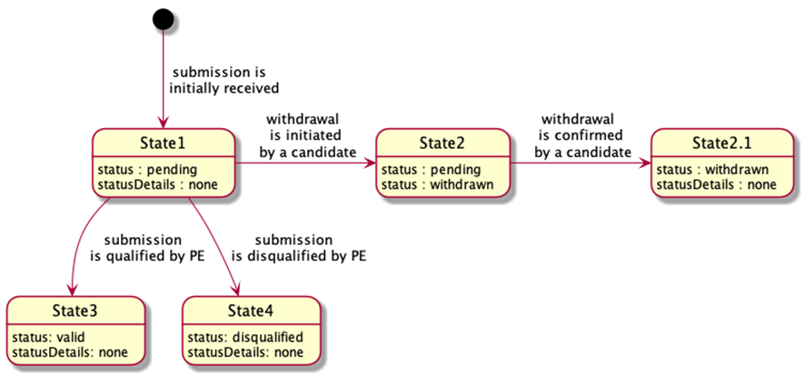

Figure 30 – State-chart diagram for submission of EoIs

All the submissions received remain confidential and closed until the expiration of the period for submission (preQualification.period.endDate). Once the deadline for submissions is reached, no submissions can be received, withdrawn or corrected.

##### State1.1 - Suspension due to non-clarification (active.suspended)

When initiation is suspended, a particular value for tender.statusDetails is used:

|  |
| --- |
| {  "tender":{  "statusDetails": "suspended"  }  } |

Figure 31 – Status of the tender

##### State8.1 - Unsuccessful completion of submission (unsuccessful.lackOfSubmissions)

If not enough submissions were collected during the EoI period, the pre-qualification phase will end unsuccessfully, with no future actions by the PE. The procurement initiation shall be moved to a phase of preparation of a negative notice.

##### Reflection of a negative completion of period for submission

The result of the pre-qualification must be reflected with preQualification.status:

* complete when enough candidates were selected for future invitation to submit a tender;
* unsuccessful when pre-qualification is unsuccessfully completed due to lack of submissions or because all the submissions were disqualified.

|  |
| --- |
| {  "preQualification": {  "status": ""  }  } |

Figure 32 – Status of the preQualification

##### Indication of the unsuccessful outcome of a procurement initiation

* For lots: A negative result under a specific lot is reflected with lot.status: unsuccessful, when the lot is closed unsuccessfully due to a lack of submissions for pre-qualification or tenders for evaluation, or when all the tenders were rejected;

|  |
| --- |
| {  "lots": [  {  "status": "unsuccessful"  }  ]  } |

Figure 33 – Unsuccessful status at lot level

* For entire initiation: A negative result under an entire initiation (procurement process) is reflected with tender.status: unsuccessful, when initiation is closed unsuccessfully due to a lack of submissions for pre-qualification or tenders for evaluation, or where all the tenders were rejected. Details of a negative closure are reflected in tender.statusDetails:
* lackOfSubmissions
* allDisqualified
* lackOfOffers
* allRejected

|  |
| --- |
| {  "tender": {  "status": "unsuccessful",  "statusDetails": ""  }  } |

Figure 34 – Unsuccessful status at tender level

##### State2 - Qualification phase (active.qualification)

##### Initiation of qualification phase

* Disclosure of the submissions: When there are enough submissions, all the submissions are disclosed as a submissions array. All the submissions’ authors are added into parties as organizations with a role: candidate.

|  |
| --- |
| {  "submissions": {  "details": [  {  "id": "1",  "requirementResponses": [  {  "id": "",  "value": "true",  "requirement": {},  "relatedTenderer": {}  },  {  "id": "",  "value": "true",  "requirement": {},  "relatedTenderer": {}  }  ],  "tenderers": [  {}  ]  }  ]  }  } |

Figure 35 – Disclosure of submissions

* Establishment of a period for qualification by the PE: In order to indicate a start of the qualification phase of a procurement process, a start date must be established adding a separate qualificationPeriod object into the preQualification building block, which will reflect a start date of the qualification phase as a system moment:

|  |
| --- |
| {  "submissions": {  "details": [  {  "preQualification": {  "qualificationPeriod": {  "startDate": ""  }  }  } |

Figure 36 – Period for Qualification

* Qualification envelopes: Along with the establishment of preQualification.qualificationPeriod.startDate, a set of qualifications is established against each submission received in order to allow the PE to reflect its decision on each submission. Such objects, based on Qualifications schema, are initially established with status:pending  and statusDetails:awaiting (*State 1* of a qualification object). Since no order is prescribed for the pre-qualification sequence, the PE can evaluate submissions received randomly.

|  |
| --- |
| {  "qualifications": [  {  "id": "",  "status": "pending",  "statusDetails": "awaiting",  "candidates": [],  "relatedSubmission": ""  }  ]  } |

Figure 37 – Status of the Qualification

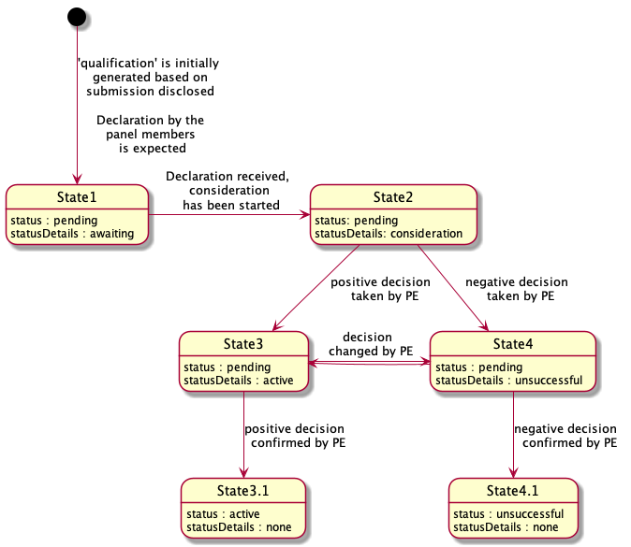

Figure 38 – State-chart diagram for Qualification

##### Declaration of non-conflict of interest

Before starting qualification, each declared member of the Evaluation Panel shall respond with a confirmation of absence of conflict of interest against each candidate from each qualification by sending relevant requirementResponses according to a common flow for declaration.

* Request of declaration: Since the declaration is the same for all members of the Evaluation Panel (either single procurement officers or all the members), it can be designed as a common requirement under specific criteria, related to the organisation appointed as a PE:

|  |
| --- |
| {  "tender": {  "criteria": [  {  "id": "",  "title": "Declaration of absence of conflict of interest and confidentiality",  "relatesTo":"procuringEntity",  "requirementGroups": [  {  "id": "",  "requirements": [  {  "id": "",  "description":,  "dataType": "boolean"  },  {  "id": "",  "description": "I confirm that I will keep all matters entrusted to me confidential. I will not communicate outside the [project team/evaluation committee] any confidential information that is revealed to me or that I have discovered. I will not make any adverse use of information given to me.",  "dataType": "boolean"  }  ]  }  ]  }  ]  }  } |

Figure 39 – Request of declaration

* Declaration: Now each declared member of the Evaluation Panel can respond with a confirmation of absence of conflict of interest against each tenderer from each award (in case of a combined evaluation under single-stage procurement) or each candidate from each qualification (in case of a multi-stage procurement with prior qualification) by sending the relevant requirementResponses.

|  |
| --- |
| {  "awards": [ // "qualifications" for multi-stage procurement with prior qualification  {  "id":"",  "requirementResponses":[  {  "id":"",  "value":true,  "requirement":{  "id":"",  "description":""  },  "relatedTenderer":{  "id":"",  "name":""  },  "responder":{  "id":"",  "name":""  }  },  {  "id":"",  "value":true,  "requirement":{  "id":"",  "description":""  },  "relatedTenderer":{  "id":"",  "name":""  },  "responder":{  "id":"",  "name":""  }  }  ]  }  ]  } |

Figure 40 – Declaration of non-conflict of interest

##### Qualification of submissions

Once all the non-conflict of interest declarations are submitted by Evaluation Committee members, the qualification for review is switched into qualification.statusDetails: consideration (State 2 of a relevant state-chart diagram of a qualification object).

* Consideration: The PE shall update qualification with all the required meta-data. By updating, the PE reflects its decision on each submission received. The PE is allowed to:
  + Add any qualification.documents if needed;
  + add qualification.requirementResponses if any relevant requirements related to the PE within the pre-qualification phase prescribed by criteria is applied;
  + add text qualification.descriptions where any justification is needed;
  + add qualification.date when any decision was taken;
  + add qualification.internalID, if any.
* Indication of a decision: Once consideration of a specific submission is complete and the related qualification is fully updated with all relevant data, the PE shall change the qualification state, reflecting a positive or negative decision in this regard:
  + qualification.statusDetails: active - state 3 of a relevant state-chart diagram of a qualification object. This means the submission is qualified and a candidate(s) will be invited to submit a commercial tender.
  + qualification.statusDetails: unsuccessful - state 4 of a relevant state-chart diagram of a qualification object. This means the submission is disqualified.

|  |
| --- |
| {  "qualifications": [  {  "id": "",  "internalid":"",  "date":"",  "status": "pending",  "statusDetails":"active"  "documents":[],  "requirementResponses":[],  "candidates": [],  "relatedSubmission": ""  },  {  "id": "",  "internalid":"",  "date":"",  "status": "pending",  "statusDetails":"unsuccessful",  "description":"This is why this candidates' submission was rejected"  "documents":[],  "requirementResponses":[],  "candidates": [],  "relatedSubmission": ""  }  ]  } |

Figure 41 – Qualification of submissions

As soon as the PE has completed the qualification and all the submissions received are updated with the relevant meta-data, the PE indicates the end of qualification.

##### State3 - Standstill period for pre-qualification (active.qualificationStandStill)

In this state, no one can take any action except the PE to switch the process to State4 or back to State2. No other actions can be prescribed for the system - all review procedures go offline and the time tracking is up to the PE.

##### Completion of qualification period

If no blockers are indicated during the stand-still period, the PE can initiate the end of the qualificationPeriod and the entire pre-qualification phase. Additional values of the endDate can be added into the preQualification.qualificationPeriod as an indication of pre-qualification completion.

|  |
| --- |
| {  "preQualification": {  "qualificationPeriod": {  "endDate": ""  }  }  } |

Figure 42 – Qualification period

##### Finalization of qualification

* Finalization of the qualifications: All the qualifications shall be moved into relevant final statuses:
  + qualification.status: pending / statusDetails: active → qualification.status: active / statusDetails: none *(state 3* to *State 3.1* of a relevant state-chart diagram of a qualification object. Means that the submission is qualified and the candidate(s) invited to submit a tender);
  + qualification.status: pending / statusDetails: unsuccessful → qualification.status: unsuccessful / statusDetails: none (*state 4* to *State 4.1* of a relevant state-chart diagram of a qualification object. Means that the submission is disqualified).
* Finalization of the submissions: All the related submissions are assigned the relevant statuses:
  + submission.status: pending where relevant qualification.status: active → submission.status: valid (*state 1* to *State 3* of a relevant state-chart diagram of a submission);
  + submission.status: pending where relevant qualification.status: unsuccessful → submission.status: disqualified (*state 1* to *State 4* of a relevant state-chart diagram of a submission).

##### Completion of qualification

The result of the pre-selecion must be reflected with preQualification.status:

* complete where enough candidates were selected for future invitation to submit a tender;
* unsuccessful where pre-qualification is unsuccessfully completed due to a lack of submissions or because all the submissions were disqualified.

|  |
| --- |
| {  "preQualification": {  "status": ""  }  } |

Figure 43 –Qualification status

##### State8.2 - Unsuccessful completion of pre-qualification (unsuccessful.allDisqualified)

Where all the submissions collected during the EoI period were disqualified, the pre-qualification phase will end unsuccessfully with no future actions by the PE. Procurement initiation shall be moved to a phase of preparation of a negative notice.

##### Completion of qualification period

If no blockers are indicated during the stand-still period, the PE can initiate the end of the qualificationPeriod and the entire pre-qualification phase.

An additional value of endDate is added into preQualification.qualificationPeriod as an indication of pre-qualification completion.

|  |
| --- |
| {  "preQualification": {  "qualificationPeriod": {  "endDate": ""  }  }  } |

Figure 44 –End date

##### Finalisation of qualification

The result of the qualification is reflected with preQualification.status:

* complete where enough candidates were selected for future invitation to submit a tender;
* unsuccessful where qualification is unsuccessfully completed due to a lack of submissions or because all the submissions were disqualified.

|  |
| --- |
| {  "preQualification": {  "status": ""  }  } |

Figure 45 –Status

##### Indication of the unsuccessful outcome of procurement initiation

* For lots: A negative result under a specific lot is reflected with lot.status: unsuccessful where the lot is closed unsuccessfully due to a lack of submissions for pre-qualification or tenders for evaluation, or where all the tenders were rejected.

|  |
| --- |
| {  "lots": [  {  "status": "unsuccessful"  }  ]  } |

Figure 46 –Unsuccessful outcome at lot level

* For entire initiation: A negative result under entire initiation (procurement process) is reflected with tender.status: unsuccessful, where initiation is closed unsuccessfully due to a lack of submissions for pre-qualification or tenders for evaluation, or where all the tenders were rejected. Details of a negative closure are reflected in tender.statusDetails:
  + lackOfSubmissions
  + allDisqualified
  + lackOfOffers
  + allRejected

|  |
| --- |
| {  "tender": {  "status": "unsuccessful",  "statusDetails": ""  }  } |

Figure 47 –Unsuccessful outcome at tender level

##### State4 - Evaluation (active.evaluation)

This state means that qualification has been conducted and technical offers requested through a call for proposals sent to the candidates selected by the PE. In case of FAs, such a call shall be implemented via publication of PAC requests either together with the publication of the FA or once qualification is performed, as detailed in section 2.5.5.

In any case, the FA remains in a ‘stand-by’ mode until tenderPeriod expires for all issued PAC requests.

##### State5 - Conclusion of a closed FA

Once evaluation is performed by the PE for each issued PAC request and a set of purchasing items is identified for each invited candidate, the FA can be concluded. All the purchasing items under the FA, together with any information related to agreed metrics of performance and conditions of execution for each selected supplier shall be collected.

To describe and reflect the parties of a concluded FA, a common inclusive contract object shall be added to a FA conclusion record:

|  |
| --- |
| "contracts": [  {  "id": "",  "indernalId": "",  "description": "",  "status": "",  "statusDetails": ""  "period": {  "startDate": "",  "endDate": ""  },  "suppliers": [],  "isFrameworkOrDynamic": false  }  ] |

Figure 48 –Conclusion of a closed FA

Such an object reflects:

* Requisites of the FA;
* period and duration;
* list of selected suppliers.

To reflect the scope of the FA together with all metrics agreed by the parties, a set of framework contracts concluded as a result of PAC requests shall be listed using a relatedProcesses array:

|  |
| --- |
| "contracts": [  {  "relatedProcesses":[  {  "id":"",  "relationship":[  "x_frameworkContract"  ],  "scheme":"ocid",  "identifier":"",  "uri":""  }  ]  }  ] |

Figure 49 –Scope of the FA

##### State6 - Completion of a procedure

##### Indication of the successful outcome of procurement initiation

* For lots: Positive result under a specific lot must be reflected with lot.status: complete.

|  |
| --- |
| {  "lots": [  {  "status": "complete"  }  ]  } |

Figure 50 –Successful outcome at lot level

* For entire initiation: Positive result under the entire initiation (procurement process) must be reflected with tender.status: complete.

|  |
| --- |
| {  "tender": {  "status": "complete"  }  } |

Figure 51 –Successful outcome at tender level

##### Pre-award catalogue request

A PAC request under a FA can be issued when:

* All terms and conditions of the procurement are established with the conclusion of the closed FA, that is, when the PE has enough information from the beginning of the process. In this case, the issuing of the PAC goes together with the publication of the CN of the FA;
* the PE doesn't have enough information or is not willing to disseminate the details before the conclusion of the closed FA. In this case, the issuing of the PAC goes right after the qualification phase, once the suppliers have already been selected.

##### State-chart diagram

The sequence of a stages applicable for a PAC request is the following:

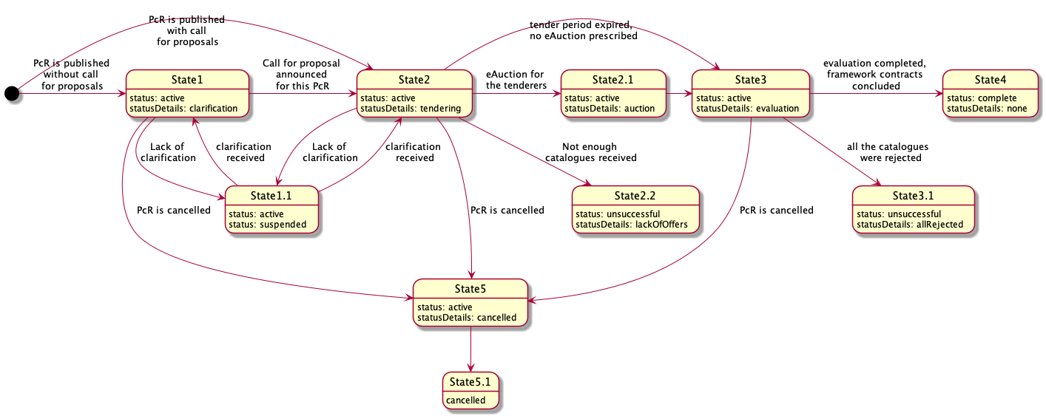

Figure 52 – State-chart diagram for a PAC request

##### OCDS dataset

##### Issuing of a PAC request

The PAC request within a FA shall include:

* List of products category determined for this request;
* minimum technical specification or a specific nomenclature, where applicable;
* lots, where applicable;
* fixed and non-fixed terms and conditions;
* awarding mechanisms and evaluation criteria and techniques.

##### State1 - Clarification (active.clarification)

In the case of publication of a PAC request (for informational purposes and for discussion but without call for proposals), the PE shall initiate a period for clarifications for all the interested suppliers.

Call for enquiries

In order to indicate a start of the explanatory phase of a procurement process, the PE shall establish a start date as an enquiry session. Such an indication shall be done by adding a separate enquiryPeriod object into the tender building block, which will reflect the end date indicated by the PE and its start date will reflect the moment of initiation of the explanatory phase in the system:

|  |
| --- |
| {  "tender": {  "enquiryPeriod": {  "startDate": "",  "endDate": ""  }  }  } |

Figure 53 – Enquiry period

##### State2 - Tendering (active.tendering)

Either after the clarification phase (State1) or together with the publication of the PAC request, the PE shall initiate a period for submission of the PAC by either any interested supplier or invited candidates.

Call for proposals

In order to indicate the start of the tendering phase of a procurement process, the PE shall establish a start date for the tendering period during which interested suppliers will be able to submit their tenders. This shall be done by adding a separate tenderPeriod object into the tender building block which will reflect the end date indicated by the PE and its start date will reflected the moment of initiation of the tendering phase in the system:

|  |
| --- |
| {  "tender": {  "tenderPeriod": {  "startDate": "",  "endDate": ""  }  }  } |

Figure 54 – Tender period

|  |
| --- |
| When the call for proposals is to be published together with the publication of a PAC request, call for enquiries is supposed to be included into the same period of time but as a separate object as described above. |

Tendering

Each invited supplier is allowed to submit a tender within the given tender.tenderPeriod indicated with the call for proposals. Each tender must be based on a bids schema and shall fulfil all the requirements prescribed by the criteria related to items or lots with a relevant list of the responses provided by the supplier (confirmative or quantifiable according to available values by applied PQQ) by providing an array of requirementResponses.

|  |
| --- |
| Having a set of requirements predefined by the PE and a number of values available for each requirement, suppliers shall specify a value for each requirement and fulfil general corporate profiles’ data as requested by the PE or required by the Legal Framework of a particular jurisdiction. |

Thus, each offer includes:

1. An organisation profile according to the extended ‘organisation’ model (or a reference on such profile previously sent while submitting an EoI, in the case of two-stage procedures);
2. set of documents of the tender, specified with relevant types of documents for their future splitting into the different "envelopes";
3. absolute financial value of the tender;
4. decomposed array of unit prices (when requested by the PE);
5. set of required responses according to criteria specified by the PE within the CN:

* Responses on requirements regarding the nature of the subject-matter of procurement;
* responses on requirements regarding the nature of the delivery and post-delivery.

|  |
| --- |
| {  "bid": {  "id": "",  "status": "",  "relatedLots": [],  "tenderers":[],  "items": [  {  "id": "",  "description": "",  "quantity": "",  "unit": {},  "relatedLot":""  }  ],  "requirementResponses":[]  }  } |

Figure 55 – Bid information

All the tenders collected remain confidential and closed until the expiration of the tendering period, tender.tenderPeriod.endDate. After tender.tenderPeriod.endDate, no tenders can be received, withdrawn or corrected.

##### State2.2 - Unsuccessful completion of tendering (unsuccessful.lackOfOffers)

Where not enough bids were collected during the tendering period for all lots, the evaluation phase will end in an unsuccessful way with no future actions by the PE. Procurement initiation shall be moved to a phase of preparation of a negative notice.

Indication of the unsuccessful outcome of procurement initiation

* For lots

A negative result under a specific lot is reflected with lot.status: unsuccessful, where the lot is closed unsuccessfully due to a lack of submissions for pre-qualification or tenders for evaluation, or where all the tenders were rejected.

|  |
| --- |
| {    "lots": [      {        "status": "unsuccessful"      }    ]  } |

Figure 56 – Unsuccessful lot

* For entire initiation (tender)

Where all the lots are unsuccessful, the entire procurement initiation goes to State8.3, which is common to any procurement method and described in a separate document (the API guide for NEPPs).

A negative result under an entire initiation (procurement process) is reflected with tender.status: unsuccessful, where initiation is closed unsuccessfully due to a lack of submissions for pre-qualification or tenders for evaluation, or where all the tenders were rejected. Details of a negative closure are reflected in tender.statusDetails

* lackOfSubmissions
* allDisqualified
* lackOfOffers
* allRejected

|  |
| --- |
| {    "tender": {      "status": "unsuccessful",  "statusDetails": ""    }  } |

Figure 57 – Unsuccessful tender

##### State3 - Evaluation (active.evaluation)

Initiation of evaluation phase

* Disclosure of the proposals

Where enough bids are received, all the tenders are disclosed as a bids array. All the authors (bid.tenderers) are updated into parties as an organizations with a role: tenderer.

|  |
| --- |
| {  "bids": {  "details":[  {  "id": "",  "status": "pending",  "statusDetails":""  "relatedLots": [],  "tenderers":[],  "items": [  {  "id": "",  "description": "",  "quantity": "",  "unit": {},  "relatedLot":""  }  ],  "requirementResponses":[]  }  }  ]  } |

Figure 58 – Disclosure of bids

* Establishment of a period for evaluation

A separate object awardPeriod is added into a tender block where the specific startDate for awarding is determined automatically. Such block is based on a Period schema.

|  |
| --- |
| {  "tender": {  "awardPeriod": {  "startDate": ""  }  }  } |

Figure 59 – Award period

* Evaluation envelopes

Along with tender.awardPeriod.startDate, a set of all tenders received during prior tendering phase must be disclosed using a bids array according to the relevant schema. All the bids authors (referring to final offers) must be updated into parties with a role: tenderer. Such objects are based on the Awards schema and are initially established with status:pending and statusDetails:none. All the submissions authors (referring to EoI or ESPD or other related documentation aimed at the qualification of the supplier) must be added into parties as an organization with a role: candidate.

|  |
| --- |
| {  "awards": [  {  "id": "",  "status": "pending",  "suppliers": [],  "relatedLots": [],  "relatedBid": ""  }  ]  } |

Figure 60 – Evaluation

* Disclosure of the enquirers

Together with the initiation of the evaluation phase, all the enquirers (tender.enquiries[*].author) must be reflected into a parties array with role: enquirer, once the tender.enquiryPeriod.endDate is achieved.

Initial ranking on award criteria

Depending on tender.awardCriteria and tenderAwardCriteriaDetails, an initial automated ranking can or cannot be done on:

|  |  |  |  |  |
| --- | --- | --- | --- | --- |
| **awardCriteriaDetatils / awardCriteria** | **priceOnly** | **costOnly** | **qualityOnly** | **ratedCriteria** |
| automated | bid.value | bid.requirementResponses * lot.value | bid.requirementResponses * 1 | bid.requirementResponses * bid.value |
| manual |  |  |  |  |

Table 18 – Award criteria

As shown in the table above, automated ranking can be undertaken automatically using a set of criteria and the relevant conversions applied by the PE for each available value of each applied requirement and published in a CN, on one hand; and the bid.requirementResponses  submitted by each supplier against published criteria on the other hand. These two data-sets allow the normalised value for each bid based on the same approach.

* Normalised price

Where normalised price must be calculated, the following formula is applied for each tender in order to identify which one is most suitable by normalised price:

*Pn = P * C1 * C2 * ... Cn*

where:

* + Pn - value of normalised price
  + P - basic price taken from bid.value or lot.value or equal to '1' depending on awardCriteria
  + C1 ... Cn - values of the coefficients to be applied (related with values of requirements, available for supplier and indicated in requirementResponses)
* Ranking approach
  + Where awardCriteria: priceOnly, only bid.value is to be compared in order to identify the most suitable tender - cheapest goes first;
  + where awardCriteria: costOnly, assumption is that all the tenderers have the bid.value equal to lot.value. This means that the normalised price needs to be calculated for each bid received, based on an estimated value lot.value - cheapest goes first;
  + where awardCriteria: qualityOnly, assumption is that the price doesn't matter and the only valuable part of the tender is the quality, meaning the set of values of criteria, selected by the supplier while submitting a tender. This means that the normalised price needs to be calculated for each bid received, based on '1';
  + where awardCriteria: ratedCriteria, assumption is that both price and quality matter. This means that the normalised price needs to be calculated for each bid received based on 'bid.value'.

Where automated ranking is the case, all the awards are ranked into order for evaluation and the first award (most suitable according to the prescribed evaluation function) will be switched to the next state ‘available for evaluation’ by the PE.

|  |
| --- |
| Depending on previously established or not established eligibility check, this state may be:   * award.statusDetails: consideration - where eligibility check took place previously; * award.statusDetails: awaiting - where eligibility check was not conducted previously by the PE. |

Consideraton

* Evauation

To evaluate the award, the PE shall update it with all the required meta-data. In these updates, the PE is allowed to:

* + Add any documents if needed;
  + Add requirementResponses if there are any relevant requirements related to the PE within the evaluation phase prescribed by tender.criteria;
  + Add text descriptions where any justification is needed;
  + Add date when the decision was taken;
  + Add internalID if any.
* Indication of a decision
* Once the evaluation of a specific tender is complete and the related award is fully updated with all relevant data, the PE shall switch the award to one of the states, reflecting a positive or negative decision:
* award.statusDetails: active - means the related bid is selected as a winning tender to be awarded;
* award.statusDetails: unsuccessful - means the related bid is rejected.

|  |
| --- |
| {  "awards": [  {  "id": "",  "description": "",  "status": "pending",  "date": "active",  "suppliers": [],  "relatedLots": [],  "relatedBid": "",  "documents": [],  "requirementResponses": [],  "indernalId": ""  }  ]  } |

Figure 61 – Awards

As soon as the PE has completed the evaluation and the winning candidates for a particular lot are identified or all the proposals under this lot are rejected, the PE indicates the end of evaluation for the lot by publishing an intention to award a contract (award decision).

Award decision

To reflect a decision regarding each specific lot and the proposal selected to be awarded with a contract (award.statusDetails:active), the PE prepares a Notice on Award Decision. This data-entity is included in a contracts array.

Since it is a stand-still period for evaluation, initially these contracts are established with a status: pending and statusDetails which reflects a decisions' outcome:

* contract.statusDetails: active where the decision regarding the lot is positive (winner is identified);
* contract.statusDetails: unsuccessful where the decision regarding the lot is negative (all the tenders were rejected).

|  |
| --- |
| {  "contracts": [  {  "id": "",  "date": "",  "awardId": "",  "status": "pending",  "statusDetails": "awaiting",  }  ]  } |

Figure 62 – Contracts

Stand-still period

In this state, no one can take any actions except the PE, who switches the process to State4 or back to State2. No other actions can be prescribed for the system - all review procedures go offline, and the time tracking is up to the PE.

Cancellation of the award decision

To reflect a decision to cancel a specific award decision taken previously under a particular lot, the PE shall switch the relevant contract object into contract.status: cancelled.

|  |
| --- |
| {  "contracts": [  {  "status": "cancelled"  }  ]  } |

Figure 63 – Contract status

Confirmation of the award decisions

If no blockers indicated during stand-still period, the PE can initiate contract preparation for the awarded lot or finalization of an unsuccessful output of a lot where all the proposals were rejected during the evaluation phase.

* Confirmation of a negative award decision

Confirmation of a negative award decision requires switching the relevant contract object to final status:unsuccessful, with a parallel indication of the reason for a negative outcome as a statusDetails:

|  |
| --- |
| {  "contracts" : [  {  "id":"",  "awardId":"",  "status":"unsuccessful",  "statusDetails": "allOffersRejected"  }  ]  } |

Figure 64 – Unsuccessful contract

* Confirmation of a positive award decision

Confirmation of a positive decision requires reflecting the subsequent contract initiation into a relevant contract object by indicating statusDetails, provided that the object remains intermediate status: pending:

|  |
| --- |
| {  "contracts" : [  {  "id":"",  "awardId":"",  "status":"pending",  "statusDetails": "contractPreparation"  }  ]  } |

Figure 65 – Status “Pending”

Contract initiation

To describe and reflect the scope of a contract to be concluded on a positive award decision, a parallel data-stream will be initiated. This stream is a separate OCDS-record where all the information related to future contracts is collected from a current procurement process. In order to establish the relation with this parallel stream, the relevant contract reflects a positive award decision and shall be extended with a relatedProcess.relationship: [x_contracting]:

|  |
| --- |
| {  "contracts" : [  {  "id":"",  "awardId":"",  "status":"pending",  "statusDetails": "contractPreparation",  "relatedProcesses": [  {  "id": "",  "relationship": [  "x_contracting"  ],  "scheme": "ocid"  }  ]  }  ]  } |

Figure 66 – Contract initiation

Contract preparation and activation

According to a common flow of [preparation of a contract to be concluded](https://ustudio.atlassian.net/wiki/spaces/VISION/pages/733511845/Preparation+of+a+Contract+to+be+concluded).

##### State3.1 - Unsuccessful completion of evaluation (unsuccessful.lackOfOffers)

Where all the bids collected during the period of tendering were rejected, the evaluation phase will end unsuccessfully with no future actions by the PE.

Completion of the evaluation phase

The completion of the evaluation phase flow is common to any procurement method and described in a separate document (the API guide for NEPPs).

Indication of the unsuccessful outcome of procurement initiation

* For lots

A negative result under a specific lot is reflected with lot.status: unsuccessful, where the lot is closed unsuccessfully due to a lack of submissions for pre-qualification or tenders for evaluation, or where all the tenders were rejected.

|  |
| --- |
| {  "lots": [  {  "status": "unsuccessful"  }  ]  } |

Figure 67 – Unsuccessful lot

* For entire initiation (tender)

A negative result under the entire initiation (procurement process) is reflected with tender.status: unsuccessful, where the initiation is closed in a negative way due to a lack of submissions for pre-qualification or tenders for evaluation, or where all the tenders were rejected. The details of a negative closure are reflected in tender.statusDetails.

* + lackOfSubmissions
  + allDisqualified
  + lackOfOffers
  + allRejected

|  |
| --- |
| {  "tender": {  "status": "unsuccessful",  "statusDetails": ""  }  } |

Figure 68 – Unsuccessful tender

##### State4 - Completion of procedure

Indication of the successful outcome of procurement initiation

* For lots

A positive result under a specific lot is reflected with lot.status: complete

|  |
| --- |
| {  "lots": [  {  "status": "complete"  }  ]  } |

Figure 69 – Successful lot

* For entire process

A positive result under an entire initiation (procurement process) is reflected with tender.status: complete.

|  |
| --- |
| {  "tender": {  "status": "complete"  }  } |

Figure 70 – Successful tender

## Execution of a closed FA

### State-chart diagrams

##### Direct award

The following diagram presents the sequence of stages applicable for the execution of a FA based on direct award following the terms and conditions of the FA, without reopening competition, by awarding a contract directly to a specific supplier applying the terms governing the provision of the works, services and supplies concerned and the objective conditions set in the FA:

Figure 71 – State-chart diagram for direct purchase under a FA

##### Mini-competition (second-stage competition)

The following diagram presents the sequence of stages applicable for the execution of a FA based on reopening of competition (partially or completely) amongst the suppliers parties to the FA:

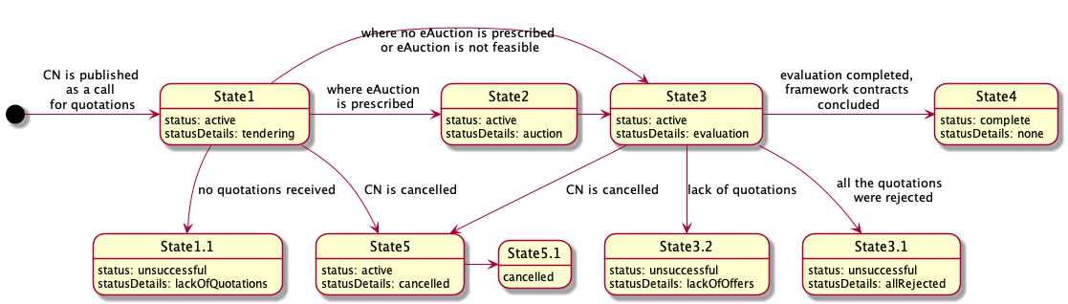

Figure 72 – State-chart diagram for mini-competition under a FA

Further detail on the different statuses is provided in section “2.5.3 OCDS dataflow” of this document.

### OCDS dataset

##### Issuing of a Direct award under a FA

This request shall be formed on the basis of the FA execution and include:

* Products category determined for this request;
* precise technical specification;
* lots (where applicable);
* specific nomenclature;
* terms and conditions which are non-fixed in the (if any);
* evaluation criteria.

|  |
| --- |
| {  "tender": {  "id": "",  "classification": {},  "status": "",  "targets": "",  "criteria": [],  "conversions": [],  "awardCriteria": "",  "awardCriteriaDetails": "",  "lots": [],  "items": [  {  "id": "",  "description": "",  "relatedLot": "",  "deliveryAddress": {},  "quantity": "",  "unit": {}  }  ]  }  } |

Figure 73 – Issuing of a direct purchase under a FA

##### Issuing of a Mini-competition (second-stage competition) under a FA

This request shall be formed on the basis of the FA execution and include:

* products category determined for this request;
* minimum technical specification (where applicable);
* lots (where applicable);
* specific nomenclature;
* terms and conditions which are non-fixed in the FA (if any);
* awarding methodology and evaluation criteria and techniques.

|  |
| --- |
| {  "tender": {  "id": "",  "classification": {},  "status": "",  "targets": "",  "criteria": [],  "conversions": [],  "awardCriteria": "",  "awardCriteriaDetails": "",  "procurementMethodModalities": [],  "lots": [],  "items": [  {  "id": "",  "description": "",  "relatedLot": "",  "deliveryAddress": {},  "quantity": "",  "unit": {}  }  ]  }  } |

Figure 74 – Issuing a mini-competition under a FA

### OCDS dataflow

##### Direct award

##### State1 - Tendering (active.tendering)

Together with the publication of the Purchase Request (PR), the PE shall initiate a period for the response by a quoted party of the FA.

##### Purchase request

In order to indicate the initiation of the period for the quoted party of a FA to respond to a PR, the PE shall establish the start and end dates of such period. This shall be done by adding a separate tenderPeriod object into the tender building block, which will reflect the end date of the period for response prescribed by the PE and its start date, reflected as a system moment of initiation of the tendering phase:

|  |
| --- |
| {  "tender": {  "tenderPeriod": {  "startDate": "",  "endDate": ""  }  }  } |

Figure 75 – Period of a purchase request

##### Response to the purchase request

The supplier that is party to the FA is the only one allowed to submit a quotation within the given tender.tenderPeriod indicated in a PR:

* Quotation is based on Bids schema.
* Quotation shall fulfil all the requirements prescribed by Criteria related to items or to lots with a relevant list of the responses by the supplier, providing an array of requirementResponses.

|  |
| --- |
| *Having a set of requirements predefined by the PE and a number of values available, the supplier preparing a submission includes values for each requirement, reflecting the substance of the quotation and fulfilling general corporate profiles’ data, as requested by the PE or required by the legal framework of a particular jurisdiction.* |

Offer includes:

1. An organization profile according to the extended Organization model (or a reference to such a profile previously sent within the FA);
2. a set of documents of the tender, specified with relevant types of documents for their future splitting into the different "envelopes";
3. absolute financial value of the tender;
4. a set of required responses according to the criteria specified by the PE within the Contract Notice (CN) related to the financial part of the offer:

* reflections on requirements characterise the nature of the subject of procurement;
* reflections on requirements characterise the nature of the delivery and post-delivery.

|  |
| --- |
| {  "bid": {  "id": "",  "status": "",  "relatedLots": [],  "tenderers":[],  "items": [  {  "id": "",  "description": "",  "quantity": "",  "unit": {},  "relatedLot":""  }  ],  "requirementResponses":[]  }  } |

Figure 76 –Information of a bid

The quotation received remains confidential and closed until expiration of the period for tendering (tender.tenderPeriod.endDate).

##### State1.1 - Unsuccessful completion of responding period (unsuccessful.lackOfOffers)

When the quoted supplier does not respond within the given period, the evaluation phase will end in an unsuccessful way with no future actions by the PE. Procurement initiation shall be moved to a phase of preparation of a negative award notice.

##### Indication of the unsuccessful outcome of procurement initiation

When absence of the requested quotation is the case, the relevant unsuccessful outcome shall be reflected for lots or for the entire PR.

For lots

A negative result under a specific lot is reflected with lot.status: unsuccessful, where the lot is closed unsuccessfully due to the lack of submission of a tender by the quoted supplier, or when the received tender was rejected.

|  |
| --- |
| {  "lots": [  {  "status": "unsuccessful"  }  ]  } |

Figure 77 – Unsuccessful lot

For entire initiation (purchase request)

Where all the lots are unsuccessful, the entire procurement initiation goes to State8.3 (described in Section 2.4.1.3 of this document).

A negative result under entire initiation (procurement process) is reflected with tender.status: unsuccessful, where the initiation is closed unsuccessfully due to the lack of submission by the quoted supplier or where the received tender was rejected. Details of a negative closure are reflected in tender.statusDetails.

|  |
| --- |
| {  "tender": {  "status": "unsuccessful",  "statusDetails": "lackOfOffers"  }  } |

Figure 78 – Unsuccessful procurement initiation

##### State8.3 - Unsuccessful completion of tendering

Where no tender was collected during the tendering period for all the announced lots, the evaluation phase will end unsuccessfully with no future actions by the PE. The procurement process shall be moved to a phase of preparation of a negative award notice.

##### State3 - Evaluation (active.evaluation)

Once the tenderPeriod.endDate is achieved, the quotation received under this request shall be fully disclosed and available for the evaluation of the PE.

##### Initiation of evaluation phase

For the evaluation of the quotation received, the following technical steps shall be performed on a system level:

Disclosure of quotation

When a quotation is provided by the quoted supplier, it is disclosed as a bid according to the relevant schema. An author (bid.tenderers) is updated into parties as an Organization with a role: tenderer.

|  |
| --- |
| {  "bids": {  "details":[  {  "id": "",  "status": "pending",  "statusDetails":""  "relatedLots": [],  "tenderers":[],  "items": [  {  "id": "",  "description": "",  "quantity": "",  "unit": {},  "relatedLot":""  }  ],  "requirementResponses":[]  }  }  ]  } |

Figure 79 – Quotation information

Establishment of a period for evaluation

A separate object awardPeriod is added into tender block where the specific start date for awarding is determined automatically. Such block is based on Period schema.

|  |
| --- |
| {  "tender": {  "awardPeriod": {  "startDate": ""  }  }  } |

Figure 80 – Period for evaluation

Evaluation envelopes

Along with the establishment of the tender.awardPeriod.startDate, the evaluation envelope – award is generated for the quotation received. This object is based on the Awards schema and is initially established with status:pending.

|  |
| --- |
| {  "awards": [  {  "id": "",  "status": "pending",  "suppliers": [],  "relatedLots": [],  "relatedBid": ""  }  ]  } |

Figure 81 – Evaluation of envelopes

##### Consideration

Evaluation

In order to evaluate the award, the PE shall update it with all the required meta-data:

* add any documents, if needed;
* add requirementResponses if there are relevant requirements related to the PE within the evaluation phase prescribed by tender.criteria;
* add text descriptions where any justification is needed;
* add date when the decision was taken;
* add internalID, if any.

Indication of a decision

Once the evaluation of the specific bid is complete and the related award is fully updated with all relevant data, the PE shall switch the award to one of the following states, reflecting a positive or negative decision:

* award.statusDetails: active - means the related bid is selected as the winning tender to be awarded;
* award.statusDetails: unsuccessful - means the related bid is rejected.

|  |
| --- |
| {  "awards": [  {  "id": "",  "description": "",  "status": "pending",  "date": "",  "suppliers": [],  "relatedLots": [],  "bidId": "",  "documents": [],  "requirementResponses": [],  "indernalId": ""  }  ]  } |

Figure 82 – Award details

As soon as the PE has completed the evaluation, the PE indicates the end of the evaluation by publishing an intention to award a contract (award decision).

##### Award decision

To reflect a decision regarding a Purchase Contract (PC), the PE prepares a Notice on Award Decision. This data-entity is based on Contract schema and is included in contracts array.

Initially, this contract is established with status: pending and a statusDetails which reflects a decisions' outcome:

* statusDetails: active - the decision regarding quotation is positive (winner is identified);
* statusDetails: unsuccessful - the decision regarding quotation is negative (the quotation was rejected).

|  |
| --- |
| {  "contracts": [  {  "id": "",  "date": "",  "awardId": "",  "status": "pending",  "statusDetails": "active",  }  ]  } |

Figure 83 – Award decision

##### Cancellation of the award decision

To reflect the decision to cancel a specific award, taken previously for a particular quotation, the PE shall switch relevant contract object into contract.status: cancelled.

|  |
| --- |
| {  "contracts": [  {  "status": "cancelled"  }  ]  } |

Figure 84 – Cancellation of the award decision

##### Confirmation of the award decision

If no blockers are indicated, the PE can initiate the contract preparation for the awarded quotation or the finalization of an unsuccessful output of a PR where the received quotation was rejected during the evaluation phase.

Confirmation of a negative award decision

Confirmation of a negative award decision requires to switch the relevant contract object into final status unsuccessful, with parallel indication of the reason for a negative outcome in statusDetails.

|  |
| --- |
| {  "contracts" : [  {  "id":"",  "awardId":"",  "status":"unsuccessful",  "statusDetails": "allOffersRejected"  }  ]  } |

Figure 85 – Negative award decision

Confirmation of a positive award decision

Confirmation of a positive decision requires reflecting the subsequent contract initiation into a relevant contract object by indicating statusDetails, provided that the object remains in an intermediate status: pending.

|  |
| --- |
| {  "contracts" : [  {  "id":"",  "awardId":"",  "status":"pending",  "statusDetails": "contractPreparation"  }  ]  } |

Figure 86 – Positive award decision

##### Contract initiation

To describe and reflect the scope of a PC to be concluded on a positive award decision, a parallel data-stream will be initiated. This stream is a separate OCDS-record where all the information related to the future contract is collected from the current procurement process. In order to establish the relation with this parallel stream, the relevant contract reflects the positive award decision and shall be extended with relatedProcess.relationship: [x_contracting].

|  |
| --- |
| {  "contracts" : [  {  "id":"",  "awardId":"",  "status":"pending",  "statusDetails": "contractPreparation",  "relatedProcesses": [  {  "id": "",  "relationship": [  "x_contracting"  ],  "scheme": "ocid"  }  ]  }  ]  } |

Figure 87 – Contract initiation

##### Contract preparation and activation

According to the common flow of eProcurement system, the preparation of a contract is concluded.

##### State3.1 - Unsuccessful completion of evaluation (unsuccessful.lackOfOffers)

If the received quotation was rejected, the evaluation phase will end in an unsuccessful way with no future actions by the PE.

##### Completion of the evaluation phase

The previously opened period for evaluation shall be closed by adding a separate endDate attribute for awardPeriod.

|  |
| --- |
| {  "tender": {  "awardPeriod": {  "endDate": ""  }  }  } |

Figure 88 –Closure of the evaluation phase

##### Indication of the unsuccessful outcome of procurement initiation

When the quotation received is rejected, the unsuccessful result shall be reflected for lots or for the entire PR.

For lots

A negative result under a specific lot is reflected with lot.status: unsuccessful, where the lot is closed in a negative way due to the lack of submission of quotation or where the received quotation was rejected.

|  |
| --- |
| {  "lots": [  {  "status": "unsuccessful"  }  ]  } |

Figure 89 – Unsuccessful lot

For entire initiation (tender)

A negative result under the entire initiation (procurement process) is reflected with tender.status: unsuccessful, where the initiation is closed in a negative way due to the lack of submission of quotation or where the received quotation was rejected. The details of a negative closure are reflected in tender.statusDetails.

|  |
| --- |
| {  "tender": {  "status": "unsuccessful",  "statusDetails": ""  }  } |

Figure 90 – Unsuccessful procurement initiation

##### State4 - Completion of procedure

##### Indication of the successful outcome of procurement initiation

When the PC was concluded under a relevant request, a positive result shall be reflected for both the lot and the entire PR:

For lots

A positive result under a specific lot is reflected with lot.status: complete.

|  |
| --- |
| {  "lots": [  {  "status": "complete"  }  ]  } |

Figure 91 – Successful lot

For entire process

A positive result under an entire initiation (procurement process) is reflected with tender.status: complete.

|  |
| --- |
| {  "tender": {  "status": "complete"  }  } |

Figure 92 – Successful procurement initiation

##### Mini-competition

##### State1 - Tendering (active.tendering)

Together with the publication of the PR, the PE shall initiate a period for submission of quotations by the suppliers that are party of the FA.

##### Call for proposals

In order to indicate the start of the tendering phase of a procurement process, the PE shall establish a start date as a call for tendering of the commercial tenders. This indication shall be done by adding a separate tenderPeriod object into the tender building block, which will reflect an end date of the tendering phase prescribed by the PE, and its start date is reflected as a system moment of initiation of the tendering phase:

|  |
| --- |
| {  "tender": {  "tenderPeriod": {  "startDate": "",  "endDate": ""  }  }  } |

Figure 93 – Period for call for proposals

##### Tendering

Each invited supplier (party to the FA) is allowed to submit a tender - quotation within the given tender.tenderPeriod indicated in the PR.

* Each quotation is based on Bids schema.
* Each quotation shall fulfil all the requirements prescribed by Criteria related to items or lots with a relevant list of the responses by the supplier, providing an array of requirementResponses.

|  |
| --- |
| Having a set of requirements predefined by the PE and a number of values available, suppliers preparing a submission include values for each requirement, reflecting the substance of the submission and fulfilling general corporate profiles’ data, as requested by the PE or required by the Legal Framework of a particular jurisdiction. |

Each tender includes:

1. An organization profile according to the extended Organization model (or a reference on such a profile previously sent within the FA);
2. a set of documents of the tender, specified with relevant types of documents for their future splitting into the different "envelopes";
3. absolute financial value of the tender;
4. a set of required responses according to the criteria specified by the PE within the PR:

* reflections on requirements characterise the nature of the subject of procurement;
* reflections on requirements characterise the nature of the delivery and post-delivery.

|  |
| --- |
| {  "bid": {  "id": "",  "status": "",  "relatedLots": [],  "tenderers":[],  "items": [  {  "id": "",  "description": "",  "quantity": "",  "unit": {},  "relatedLot":""  }  ],  "requirementResponses":[]  }  } |

Figure 94 – Information on bids

All the tenders collected remain confidential and closed until the expiration of the period for tendering (tender.tenderPeriod.endDate). Once the tender.tenderPeriod.endDate is achieved, no tenders can be received, withdrawn or corrected.

##### State1.1 - Unsuccessful completion of tendering (unsuccessful.lackOfOffers)

Where not enough tenders were collected during the tendering period for all the announced lots, the evaluation phase will end unsuccessfully with no future actions by the PE. The procurement process shall be moved to a phase of preparation of a negative award notice.

##### Indication of the unsuccessful outcome of procurement

When absence of tenders is the case, the relevant unsuccessful outcome shall be reflected for lots or for the entire PR.

For lots

A negative result under a specific lot is reflected with lot.status: unsuccessful, where the lot is closed unsuccessfully due to the lack of submission of tenders by the suppliers party to the FA, or when the received tenders were rejected.

|  |
| --- |
| {  "lots": [  {  "status": "unsuccessful"  }  ]  } |

Figure 95 – Unsuccessful lot

For entire initiation (purchase request)

When all the lots are unsuccessful, the entire procurement initiation goes to State8.3 (described in Section 2.4.1.3 of this document).

A negative result under the entire initiation (procurement process) is reflected with tender.status: unsuccessful, where the initiation is closed unsuccessfully due to the lack of submission of tenders by the suppliers party to the FA, or when the received tenders were rejected. Details of a negative closure are reflected in tender.statusDetails.

|  |
| --- |
| {  "tender": {  "status": "unsuccessful",  "statusDetails": "lackOfOffers"  }  } |

Figure 96 – Unsuccessful purchase request

##### State 2 - Auction (active.auction)

Where electronic auction as a technique for the awarding of the contract was prescribed in the PR, all the tenders received shall be partially disclosed in order to establish an auction.

##### State3 - Evaluation (active.evaluation)

Once the tenderPeriod.endDate is achieved (when electronic auction was not prescribed in the PR) or when the electronic auction is completed, all tenders received under this request shall be fully disclosed and available for the evaluation of the PE.

##### Initiation of evaluation phase

For the evaluation of the tenders received, the following technical steps shall be performed on a system level.

Disclosure of tenders

Tenders are disclosed in a bids array. Authors (bid.tenderers) are updated into parties as an Organization with a role: tenderer.

|  |
| --- |
| {  "bids": {  "details":[  {  "id": "",  "status": "pending",  "statusDetails":""  "relatedLots": [],  "tenderers":[],  "items": [  {  "id": "",  "description": "",  "quantity": "",  "unit": {},  "relatedLot":""  }  ],  "requirementResponses":[]  }  }  ]  } |

Figure 97 – Bids information

Establishment of a period for evaluation

A separate object awardPeriod is added into tender block where the specific start date for awarding is determined automatically. Such block is based on a Period schema.

|  |
| --- |
| {  "tender": {  "awardPeriod": {  "startDate": ""  }  }  } |

Figure 98 – Evaluation period

Evaluation envelopes

Along with the establishment of the tender.awardPeriod.startDate, an evaluation envelope – award is generated for each tender received. These objects are based on the Awards schema and are initially established with status:pending.

|  |
| --- |
| {  "awards": [  {  "id": "",  "status": "pending",  "suppliers": [],  "relatedLots": [],  "relatedBid": ""  }  ]  } |

Figure 99 – Evaluation of envelopes

Disclosure of enquirers

Together with the initiation of the evaluation phase, all enquirers (tender.enquiries[*].author) are reflected into parties array according to Organization block schema with role: enquirer.

##### Initial ranking on award criteria

Depending on tender.awardCriteria and tenderAwardCriteriaDetails, an initial automated ranking can or cannot be done:

|  |  |  |  |  |
| --- | --- | --- | --- | --- |
| **awardCriteriaDetatils / awardCriteria** | **priceOnly** | **costOnly** | **qualityOnly** | **ratedCriteria** |
| automated | bid.value | bid.requirementResponses * lot.value | bid.requirementResponses * 1 | bid.requirementResponses * bid.value |
| manual |  |  |  |  |

Table – Automated and manual award criteria depending on the ranking approach

As shown in the table above, automated ranking can be undertaken automatically using a set of criteria and the relevant conversions applied by the PE for each available value of each applied requirement published in a CN, on one hand; and the bid.requirementResponses submitted by each supplier party to the FA against published criteria on the other hand. These two data-sets allow the normalised value for each bid based on the same approach to be calculated.

Normalised price

Where normalised price must be calculated, the following formula is applied for each tender in order to identify which one is most suitable by normalised price:

*Pn = P * C1 * C2 * ... Cn*

where:

* Pn - value of normalised price
* P - basic price taken from bid.value or lot.value or equal to '1' depending on awardCriteria
* C1 ... Cn - values of the coefficients to be applied (related with values of requirements, available for supplier and indicated in requirementResponses)

Ranking approach

* priceOnly

Where awardCriteria: priceOnly - only bid.value is compared in order to identify the most suitable tender. Cheapest goes first.

* costOnly

Where awardCriteria: costOnly – the assumption is that all the tenderers have the same bid.value equal to lot.value. It means that the normalised price needs to be calculated for each bid received based on lot.value as a basis. Cheapest goes first.

* qualityOnly

Where awardCriteria: qualityOnly – the assumption is that the price doesn't matter and the only valuable part of the tender is quality - meaning set of values of criteria, selected by the supplier while submitting a bid. It means that the normalised price needs to be calculated for each bid received, based on '1'. Most qualified goes first.

* ratedCriteria

Where awardCriteria: ratedCriteria – the assumption is that both price and value matter. It means that the normalised price needs to be calculated for each bid received based on ‘bid.value'.

Where automated ranking is the case, all the awards are ranked into order for evaluation and the first award (most suitable according to the prescribed evaluation function) will be switched to the next state ‘available for evaluation’ by the PE.

##### Consideration

Evaluation

In order to evaluate an award, the PE shall update it with all the required meta-data:

* Add any documents, if needed;
* add requirementResponses if there are relevant requirements related to the PE within the evaluation phase prescribed by tender.criteria;
* add text descriptions where any justification is needed;
* add date when the decision was taken;
* add internalID, if any.

Indication of a decision

Once the evaluation of a specific bid is complete and the related award is fully updated with all relevant data, the PE shall switch the award to one of the following states, reflecting a positive or negative decision:

* award.statusDetails: active - means the related bid is selected as a winning tender to be awarded;
* award.statusDetails: unsuccessful - means the related bid is rejected.

|  |
| --- |
| {  "awards": [  {  "id": "",  "description": "",  "status": "pending",  "date": "",  "suppliers": [],  "relatedLots": [],  "bidId": "",  "documents": [],  "requirementResponses": [],  "indernalId": ""  }  ]  } |

Figure 100 –Information on the award

As soon as the PE has completed the evaluation and the winning tender for each lot is identified or all the tenders for this lot are rejected, the PE indicates the end of the evaluation for the lot by publishing an intention to award a PC (award decision).

##### Award decision

To reflect the decision regarding each lot and the tender selected to be awarded a PC (award.statusDetails:active), the PE prepares a Notice on Award Decision. This data-entity is based on Contract schema and included in contracts array.

Initially, this contract is established with status: pending and statusDetails which reflect a decisions' outcome:

* statusDetails: active where the decision regarding the lot is positive (winner is identified);
* statusDetails: unsuccessful where the decision regarding the lot is negative (all tenders were rejected).

|  |
| --- |
| {  "contracts": [  {  "id": "",  "date": "",  "awardId": "",  "status": "pending",  "statusDetails": "contractProject",  }  ]  } |

Figure 101 – Award decision

##### Cancellation of the award decision

To reflect a decision to cancel a specific award decision taken previously for a particular lot, the PE shall switch relevant contract object into contract.status: cancelled.

|  |
| --- |
| {  "contracts": [  {  "status": "cancelled"  }  ]  } |

Figure 102 – Cancellation of award decision

##### Confirmation of the award decision

If no blockers are identified, the PE can initiate the contract preparation for the awarded lot or the finalization of an unsuccessful output of the lot.

Confirmation of a negative award decision

Confirmation of negative award decision requires to switch the relevant contract object into final status unsuccessful, with a parallel indication of the reason for a negative outcome as statusDetails.

|  |
| --- |
| {  "contracts" : [  {  "id":"",  "awardId":"",  "status":"unsuccessful",  "statusDetails": "allOffersRejected"  }  ]  } |

Figure 103 – Confirmation of award decision

Confirmation of a positive award decision

Confirmation of a positive decision requires reflecting the subsequent contract initiation into a relevant contract object by indicating statusDetails, provided that the object remains in an intermediate status: pending.

|  |
| --- |
| {  "contracts" : [  {  "id":"",  "awardId":"",  "status":"pending",  "statusDetails": "contractPreparation"  }  ]  } |

Figure 104 – Positive award decision

##### Contract initiation

To describe and reflect the scope of a PC to be concluded on a positive award decision, a parallel data-stream will be initiated. This stream is a separate OCDS-record where all the information related to the future PC is collected from the current procurement process.

In order to establish the relation with this parallel stream, the relevant contract reflects the positive award decision and shall be extended with relatedProcess.relationship: [x_contracting].

|  |
| --- |
| {  "contracts" : [  {  "id":"",  "awardId":"",  "status":"pending",  "statusDetails": "contractPreparation",  "relatedProcesses": [  {  "id": "",  "relationship": [  "x_contracting"  ],  "scheme": "ocid"  }  ]  }  ]  } |

Figure 105 – Contract initiation

##### Contract preparation and activation

According to the common flow of the eProcurement system, the preparation of a contract is concluded.

##### State3.2 - Unsuccessful completion of evaluation (unsuccessful.lackOfOffers)

When all the tenders collected during the period of tendering were rejected, the evaluation phase will end unsuccessfully with no future actions by the PE.

##### Completion of the evaluation phase

The previously opened period for evaluation shall be closed by adding a separate endDate attribute for awardPeriod:

|  |
| --- |
| {  "tender": {  "awardPeriod": {  "endDate": ""  }  }  } |

Figure 106 – Closure of the evaluation phase

##### Indication of the unsuccessful outcome of procurement initiation

Where all received tenders are rejected, the unsuccessful result shall be reflected for lots or for the entire PR.

For lots

A negative result under a specific lot is reflected with lot.status: unsuccessful, where the lot is closed in a negative way due to the lack of submission of tenders or where all the received tenders were rejected.

|  |
| --- |
| {  "lots": [  {  "status": "unsuccessful"  }  ]  } |

Figure 107 – Unsuccessful completion of procedure at lot level

For entire initiation (tender)

A negative result under the entire initiation (procurement process) is reflected with tender.status: unsuccessful, where the initiation is closed in a negative way due to the lack of submission of tenders or where all the received tenders were rejected. The details of a negative closure are reflected in tender.statusDetails.

|  |
| --- |
| {  "tender": {  "status": "unsuccessful",  "statusDetails": "allRejected"  }  } |

Figure 108 – Unsuccessful completion of procedure at tender level

##### State4 - Completion of procedure

##### Indication of the successful outcome of procurement initiation

Where PC was concluded under relevant request, a positive outcome of a process shall be reflected for both lot and entire PR:

For lots

A positive result under a specific lot is reflected with lot.status: complete.

|  |
| --- |
| {  "lots": [  {  "status": "complete"  }  ]  } |

Figure 109 – Successful completion of procedure at lot level

For entire process

A positive result under an entire initiation (procurement process) is reflected with tender.status: complete.

|  |
| --- |
| {  "tender": {  "status": "complete"  }  } |

Figure 110 – Successful completion of procedure at tender level

1. <https://app.lucidchart.com/publicSegments/view/b09729c6-cc4d-44ce-be4d-2afbe2e96195/image.png>
2. <https://cawemo.com/share/4936b1c7-4467-432d-aee6-1b2cc8b3be03>
3. <https://cawemo.com/share/59721d1d-458a-4af4-9af7-c9577a97b62f>
4. <https://cawemo.com/share/23f00821-b867-413d-b62c-eb482f34a1d6>
5. <https://cawemo.com/share/1ae8009c-d717-4ad0-aabc-f4b87337b925>
6. Functionality based on the European Single Procurement Document defined in Article 59 of the [Directive 2014/24/EU](https://eur-lex.europa.eu/legal-content/EN/TXT/?uri=celex%3A32014L0024) of the European Parliament and of the Council of 26 February 2014 on public procurement